

Lab manual
Data mining

Submitted to:
Mr. Muhammad Arham

Submitted by:
Taibah Shahbaz 2023-BS-AI-024 (6A)

Department:
Artificial intelligence

Contents
LAB-1: Introduction to Data Mining Software & Datasets 3
LAB-2: CRISP-DM Process & Data Types 7
LAB-3: Data Cleaning Techniques 13
LAB-4: Data Preprocessing 21
LAB-5: Market Basket Analysis 27
LAB-6: Apriori Algorithm 29
LAB-7: FP-Tree & FP-Growth 34
LAB-8: Python Basics for Data Mining 41
LAB-9: Decision Tree 44
LAB-10: Naïve Bayes & KNN 49
LAB-11: Support Vector Machine (SVM) 56
LAB-12: Clustering Algorithms 61
LAB-13: Outlier Detection Techniques 69
LAB-14: Web Scraping & Sentiment Analysis 74
Lab 15: Final Capstone Project 91

LAB-1: Introduction to Data Mining Software & Datasets

Data mining software consists of specialized tools and platforms designed to discover meaningful patterns, relationships, and insights from large volumes of data. These tools play a crucial role in transforming raw data into valuable information that supports decision-making and forecasting.
Some commonly used data mining tools include Python (along with libraries such as Pandas, NumPy, and Scikit-learn), RapidMiner, Orange, and WEKA. These platforms are widely adopted across industries due to their ability to perform various tasks like data preprocessing, visualization, classification, clustering, and association rule mining.
Additionally, data mining software helps automate repetitive processes and efficiently manage large-scale datasets. In practical applications, organizations use these tools to study customer behavior, forecast future trends, and enhance business strategies for better outcomes.
Example:
An online retail company can use data mining software to analyze purchase history and recommend products to customers based on their previous buying patterns.
Datasets
A dataset refers to an organized collection of data, typically arranged in a tabular format consisting of rows and columns. In this structure, each row corresponds to a specific record or instance, while each column represents a particular feature or attribute.
Datasets can be categorized into three main types:
- Structured Data: This type of data is highly organized and usually stored in databases in the form of tables.
- Unstructured Data: This includes data that does not follow a predefined format, such as text documents, images, and videos.
- Semi-structured Data: This type lies between structured and unstructured data, often found in formats like JSON and XML, where some organizational properties exist.
1. Objective
The objective of this lab is to introduce students to data import, basic structural inspection, and exploratory data analysis (EDA). Students will learn how to profile a retail store's dataset, identify data formats, and generate baseline statistical summaries to extract immediate business insights.
2. Tools & Datasets
- Tool: KNIME Analytics Platform
- Dataset: Supermarket Sales / Retail Sales Dataset (Kaggle)
3. Background Concepts
Before running complex predictive algorithms, a data analyst must perform Data Profiling. This involves checking what types of data are in the columns and computing general statistics to understand data boundaries.
- Data Types: Understanding if an attribute is Nominal/Categorical (e.g., Product Line, Gender) or Numerical/Continuous (e.g., Unit Price, Quantity, Total Revenue).
- Summary Statistics: * Mean (Average): The central tendency of the data.
  - Median: The exact middle value, highly useful when data contains extreme price outliers.
  - Standard Deviation: Measures how spread out the values are around the mean.
Lab work
Search dataset
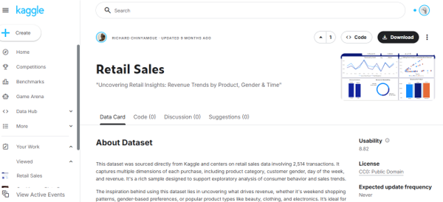
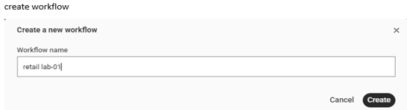
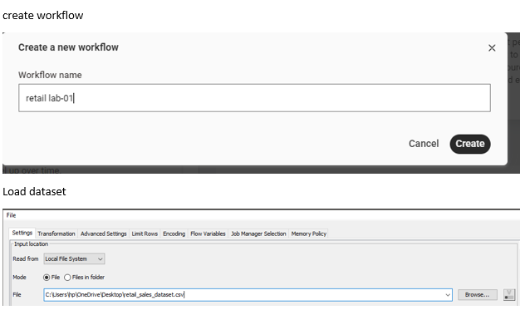
Connect statistics node
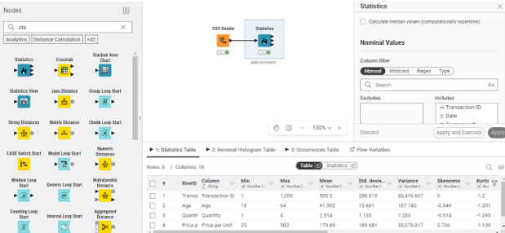
Use group by
KPI 1
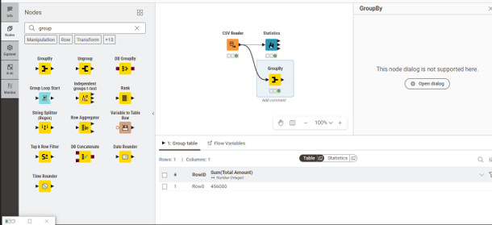
KPI 2
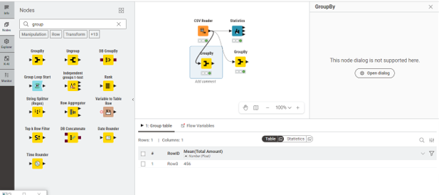
KPI 3
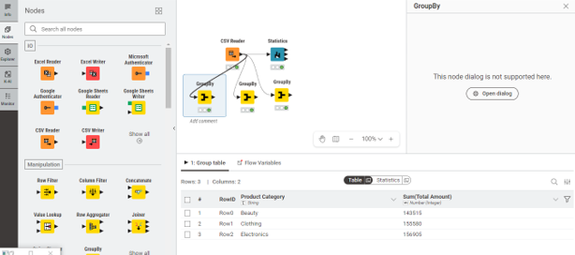
Scatter node
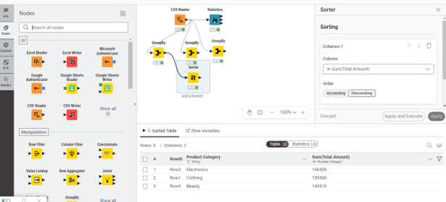

LAB-2: CRISP-DM Process & Data Types

1. Objective
The objective of this lab is to introduce students to the CRISP-DM (Cross-Industry Standard Process for Data Mining) methodology. Students will map a real-world e-commerce customer churn problem across the standard CRISP-DM phases, execute data preparation, and build a predictive classification model.
2. Tools & Datasets
- Tool: Orange Data Mining
- Dataset: Customer Churn Dataset (Available on Kaggle)
3. Background Concepts
The CRISP-DM methodology provides a structured, iterative approach to managing data science projects. It breaks down a project lifecycle into six core phases:
- Business Understanding: Aligning project goals with business problems (e.g., "Why are e-commerce customers leaving?").
- Data Understanding: Collecting, exploring, and identifying quality issues in the customer dataset.
- Data Preparation: Selecting, cleaning, and transforming raw records into a final model-ready layout.
- Modeling: Selecting and applying various machine learning algorithms (e.g., Logistic Regression or Random Forest).
- Evaluation: Checking if the model mathematically meets business thresholds before deployment.
- Deployment: Integrating the insights or model into active business operations.
Types of Data
Data can be categorized into different types depending on its characteristics and usage:
- Numerical Data:
Includes quantitative values that can be measured. It can be:
  - Discrete (e.g., number of courses taken)
  - Continuous (e.g., height or temperature)
- Categorical Data:
Represents qualitative values and is divided into:
  - Nominal (e.g., department names like IT, HR)
  - Ordinal (e.g., performance levels such as low, medium, high)
- Binary Data:
Consists of only two possible values, such as yes/no or true/false.
Understanding these data types is essential because different algorithms work better with specific types of data. Choosing the correct type ensures better model accuracy and performance.
Dataset
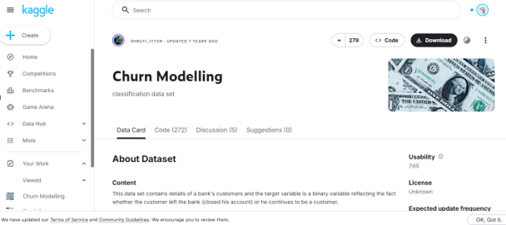
Load dataset
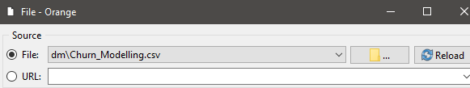
Check on data table
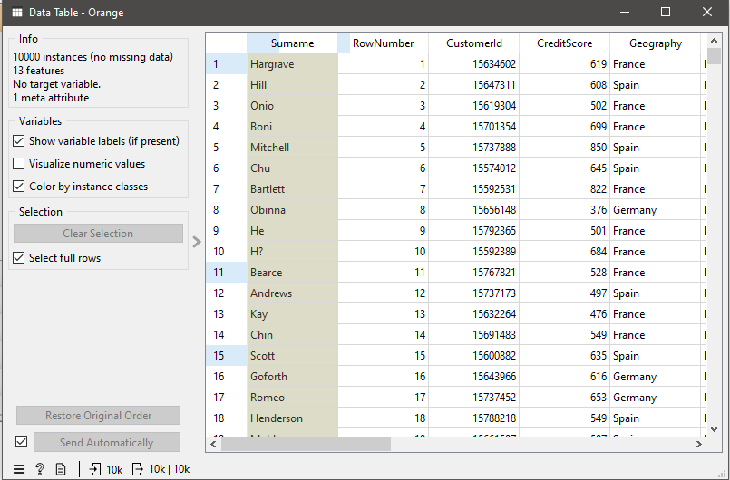
Attach datatable to file.
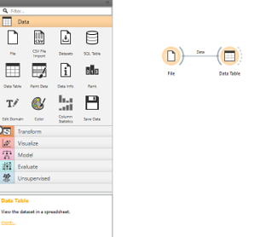
Then connect select column to it.
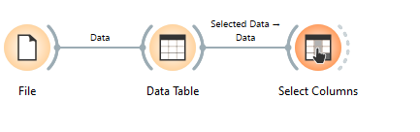
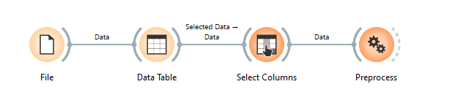
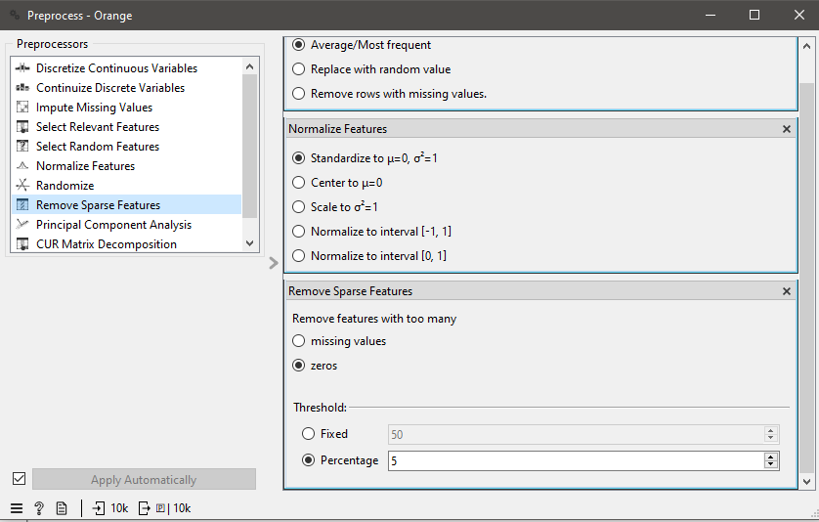
Connect logistic regression and random forest classifier and then connect test and score to it.
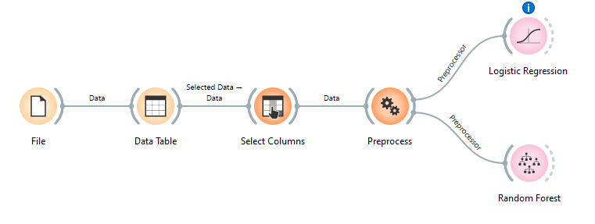
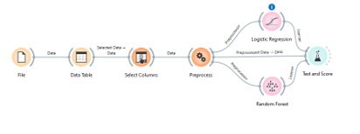
Test and score:
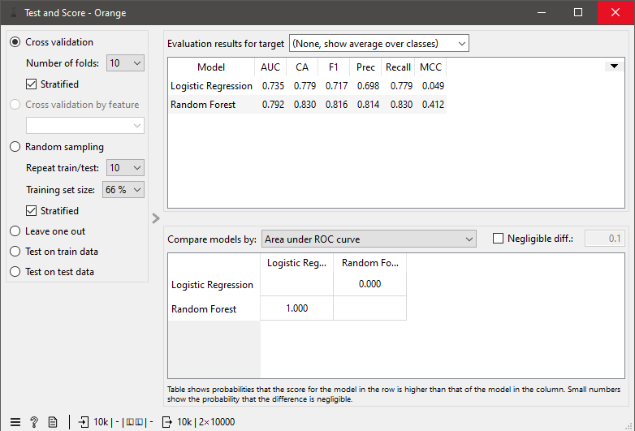
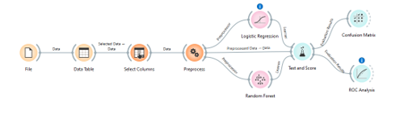

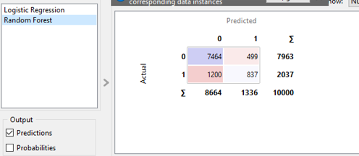
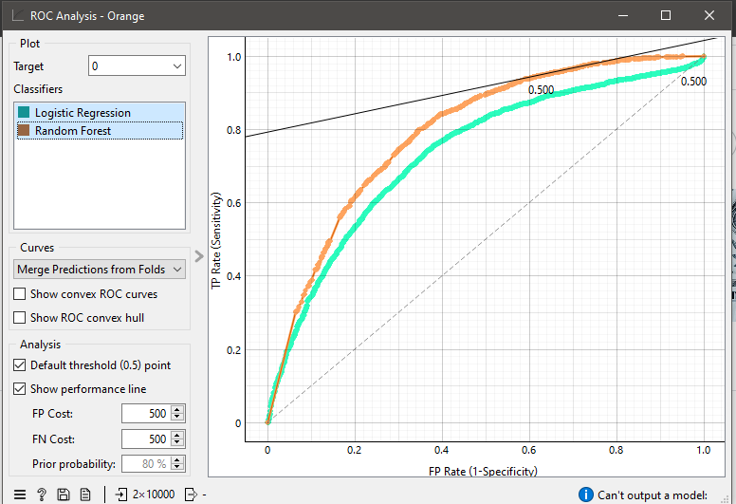

Churn Rate | 20.37%
Retention Rate | 79.63%
Logistic Regression AUC | 0.735
Random Forest AUC | 0.792
Accuracy | 82.8%

LAB-3: Data Cleaning Techniques

1. Objective
The objective of this lab is to prepare raw, imperfect healthcare data for downstream analytics. Students will learn how to handle missing data, eliminate duplicate records, and apply noise-filtering techniques to improve overall data quality.
2. Tools & Datasets
- Tools: RapidMiner Studio & Python
- Dataset: Healthcare Dataset / Patient Records
3. Background Concepts
Data cleaning is the most critical phase of data preprocessing. In healthcare analytics, dirty data can lead to dangerous, incorrect insights.
- Missing Values: Can be handled by deletion (dropping rows/columns) or imputation (replacing with Mean, Median, Mode, or predictive values).
- Duplicates: Identical rows that artificially skew statistical distributions.
- Noise Filtering: Removing outliers or incorrect formatting that disrupts model patterns.
Lab Work on RapidMiner Studio
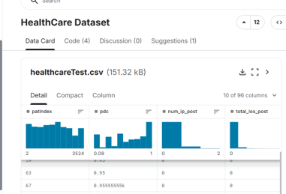
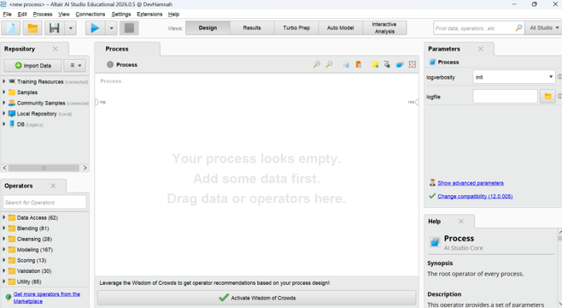
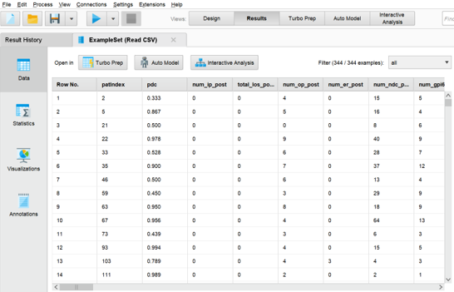
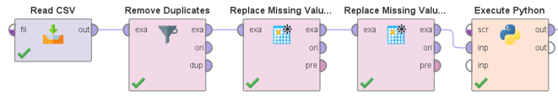
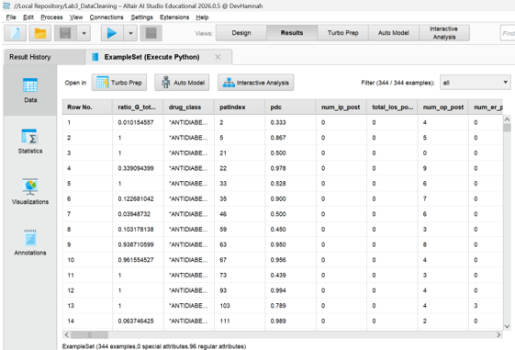
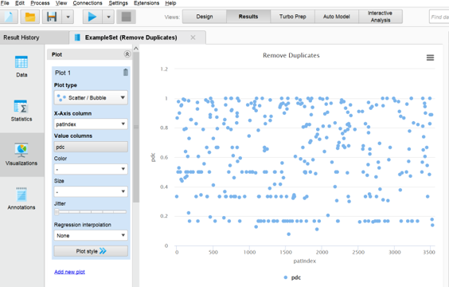
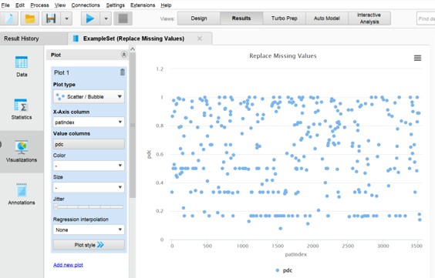
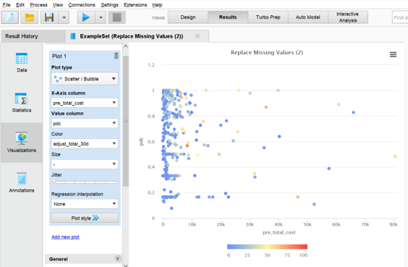

Lab Work on python
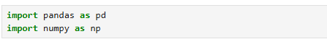
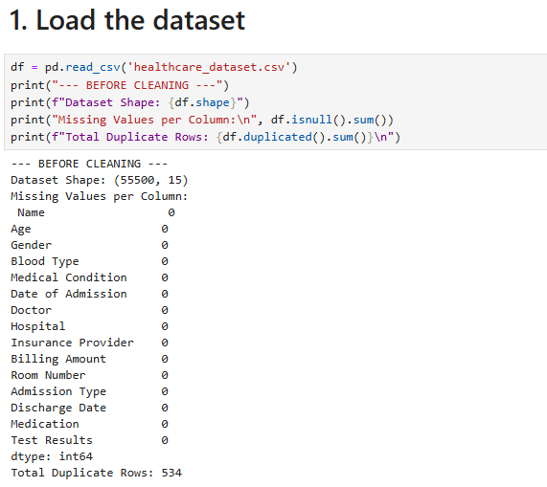
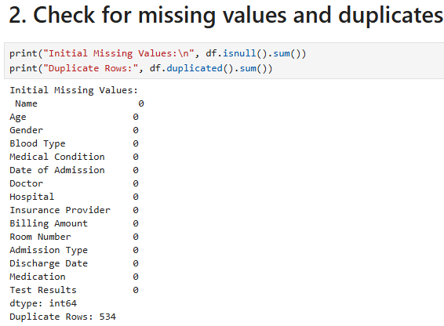
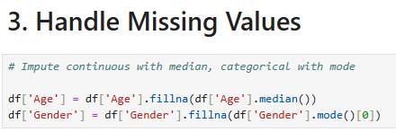
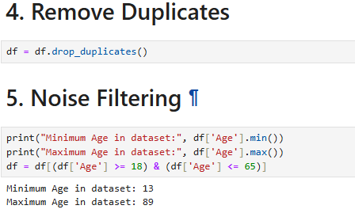
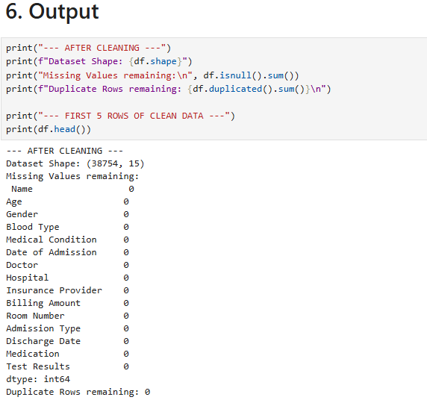
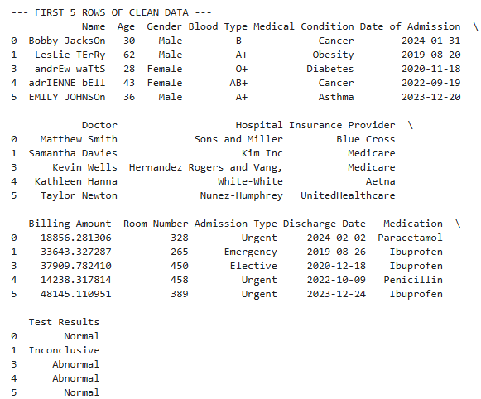
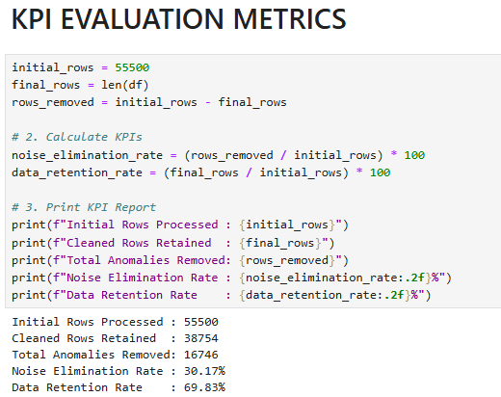

LAB-4: Data Preprocessing

1. Objective
The objective of this lab is to transform cleaned loan risk data into a mathematically balanced and optimized format ready for machine learning models. Students will master advanced feature transformation techniques, including data normalization, standardization, and discretization (binning).
2. Tools & Datasets
- Tool: RapidMiner Studio
- Dataset: Loan Prediction Dataset / Bank Dataset (Available on Kaggle)
3. Background Concepts
Raw data often contains features with completely different scales (e.g., an Applicant Income attribute ranging from $1,000 to $100,000, vs. a Credit Score attribute ranging from 300 to 850). Algorithms that rely on distance calculations can get distorted by these scale differences.
- Normalization (Min-Max Scaling): Transforms data linearly into a fixed range, typically between 0 and 1.
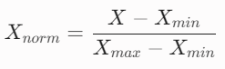
- Standardization (Z-Score): Centers the data around a mean ($\mu$) of 0 with a standard deviation ($\sigma$) of 1. Ideal for data that follows a Gaussian (normal) distribution.
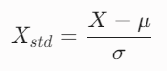
- Discretization (Binning): The process of converting continuous numeric attributes into categorical group buckets (e.g., transforming numerical age into "Young", "Middle-Aged", and "Senior").

Lab Work on RapidMiner Studio
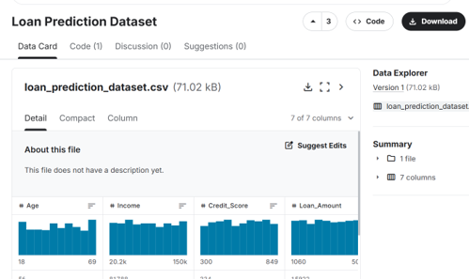
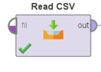
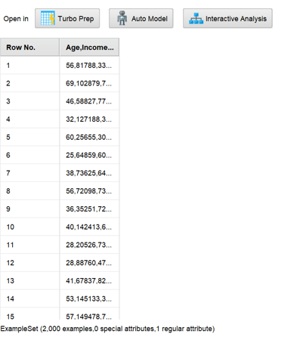
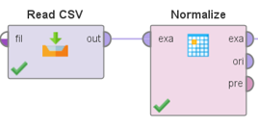
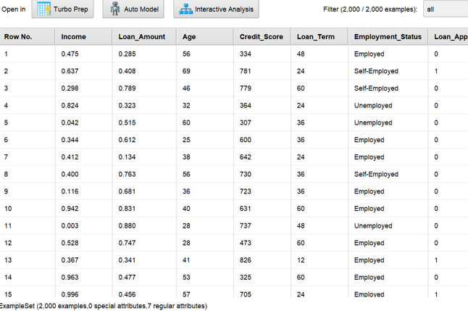
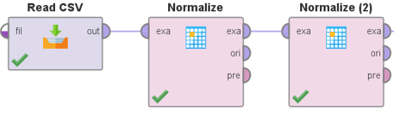
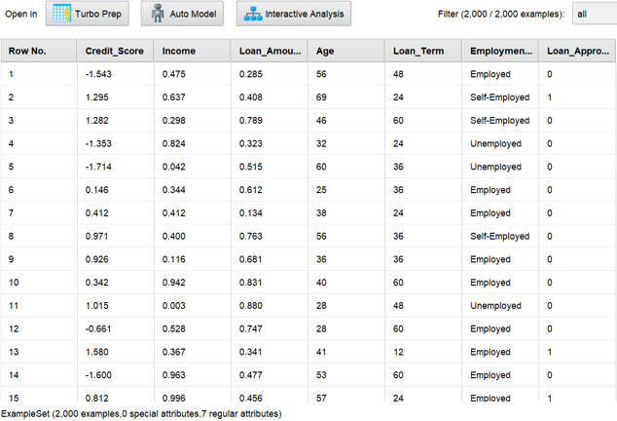
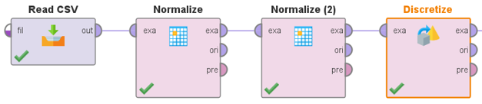
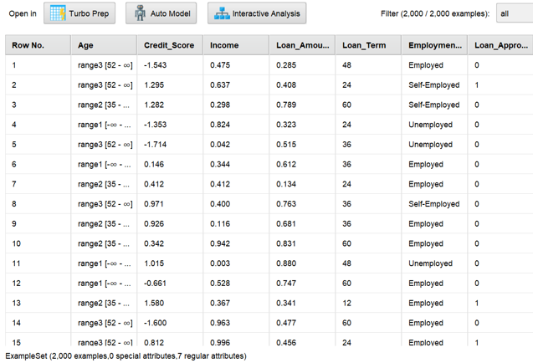
Lab work on python
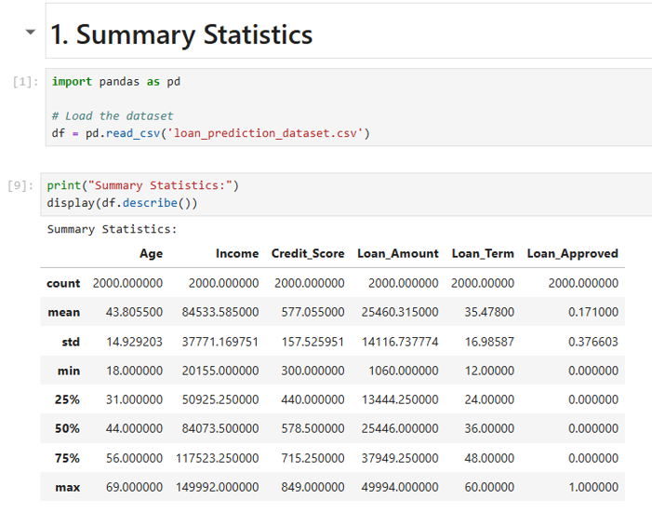
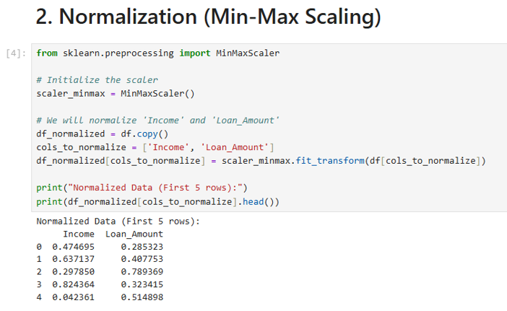
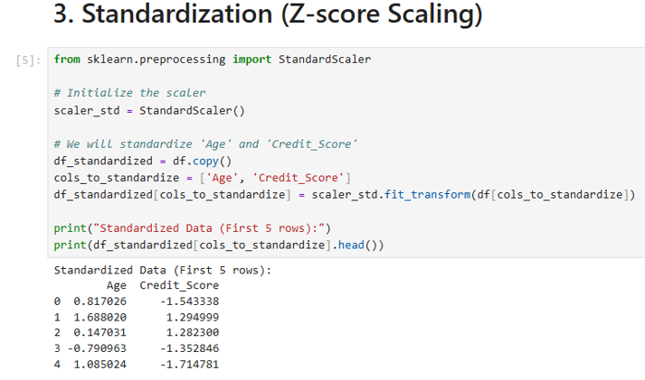
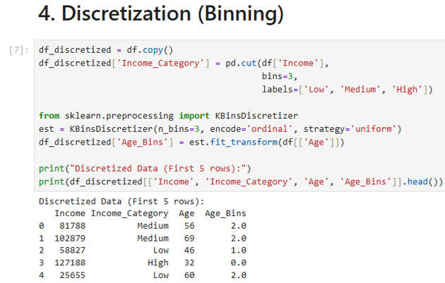

LAB-5: Market Basket Analysis

1. Objective
The objective of this lab is to understand and implement association rule mining using Market Basket Analysis (MBA). Students will learn how a supermarket develops cross-selling strategies by calculating key association metrics—Support, Confidence, and Lift—manually, and validating their results programmatically using Python.
2. Tools & Datasets
- Tool: Python (Pandas & Mlxtend)
- Dataset: Grocery Transactions Dataset / Instacart Market Basket Analysis (Kaggle)
3. Background Concepts
Market Basket Analysis searches for behavioral combinations among customer purchases. It answers questions like, "If a customer buys product X, how likely are they to buy product Y?"
To find these relationships, we evaluate Association Rules (written as X->Y, where X is the Antecedent and Y is the Consequent) using three fundamental mathematical metrics:
- Support: The proportion of total transactions that contain the itemset. It measures how frequently an itemset appears.
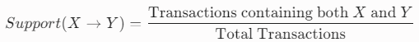
- Confidence: The conditional probability that a customer buys item $Y$, given that they have already purchased item $X$. It measures the reliability of the rule.
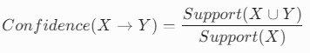
- Lift: Measures how much more likely item $Y$ is to be bought relative to its ordinary, random baseline sales rate when item $X$ is purchased.
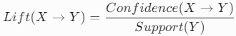
  - Lift = 1$: $X$ and $Y$ are independent.
  - Lift > 1$: Positive association (strong cross-sell potential).
  - Lift < 1$: Negative association (items substitute or repel each other).
Lab task
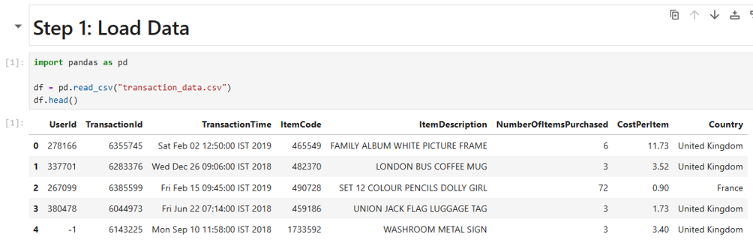
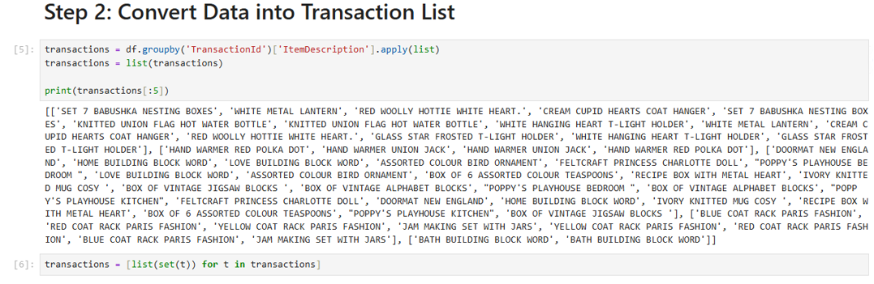
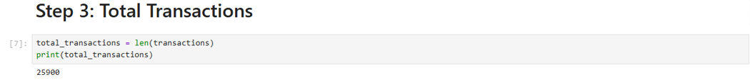
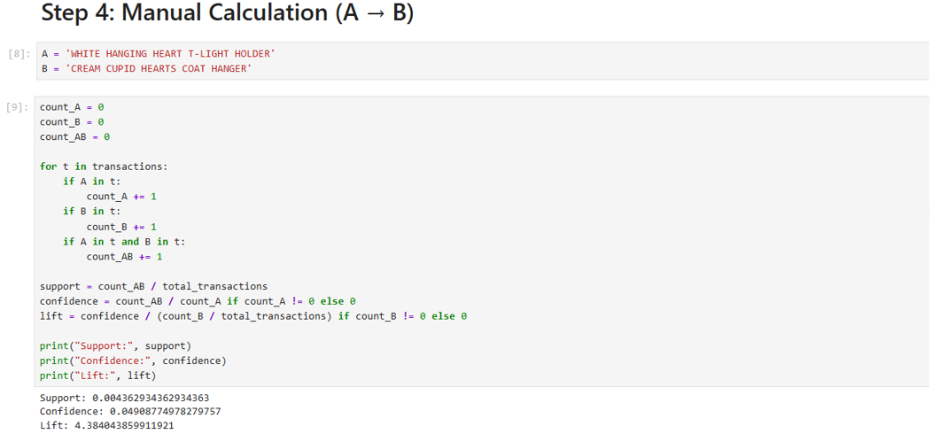
LAB-6: Apriori Algorithm
1. Objective
The objective of this lab is to understand, implement, and analyze the systematic mechanics of the Apriori Algorithm. Students will learn how to identify frequent product combinations and generate reliable association rules by enforcing minimum support and confidence thresholds using Python.
2. Tools & Datasets
- Tool: Python / KNIME / RapidMiner
- Dataset: Transaction Dataset
3. Background Concepts
While Market Basket Analysis defines the core metrics (Support, Confidence, Lift), the Apriori Algorithm provides an efficient algorithmic approach to mine those rules out of massive datasets.
The biggest challenge in association rule mining is the combinatorial explosion: if a store has $d$ unique items, there are $2^d$ possible itemsets to check. Apriori solves this using the Apriori Principle (Downward Closure Property):
Any subset of a frequent itemset must also be frequent. Conversely, if an itemset is infrequent, all of its supersets will automatically be infrequent and can be pruned without ever being tested.
The algorithm operates in a two-step iterative cycle:
- Candidate Generation ($C_k$): Joining frequent itemsets from the previous pass ($L_{k-1}$) to create larger candidate combinations.
- Support Counting and Pruning ($L_k$): Scanning the database to calculate the actual support of candidates, keeping only those that satisfy the minimum support threshold ($min\_sup$).
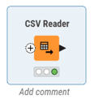
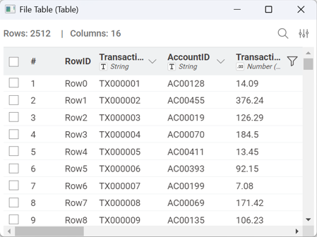
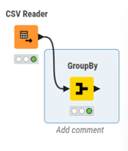
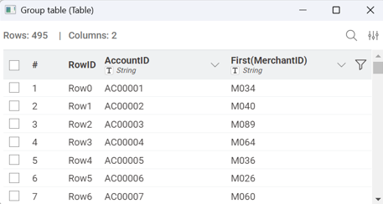
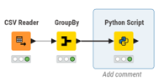
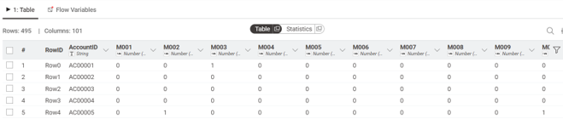
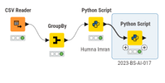
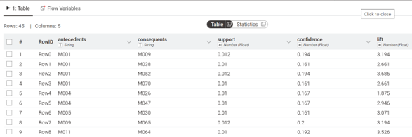
Importing libraries:
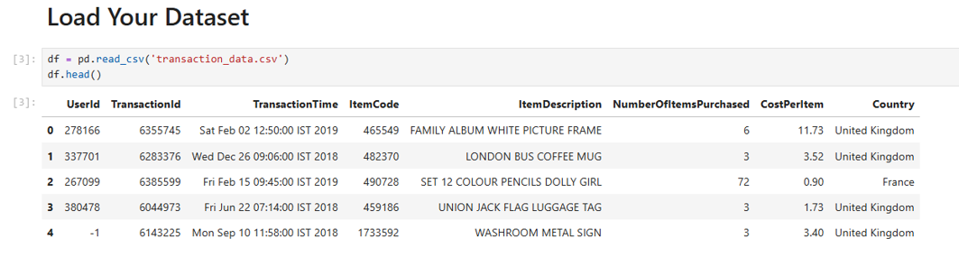
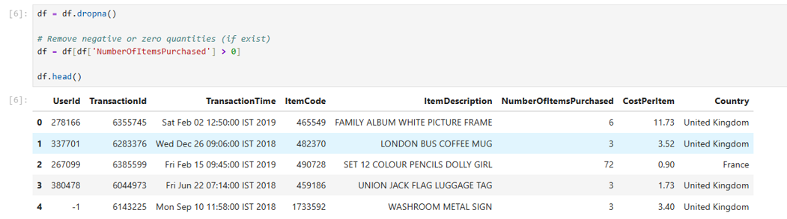
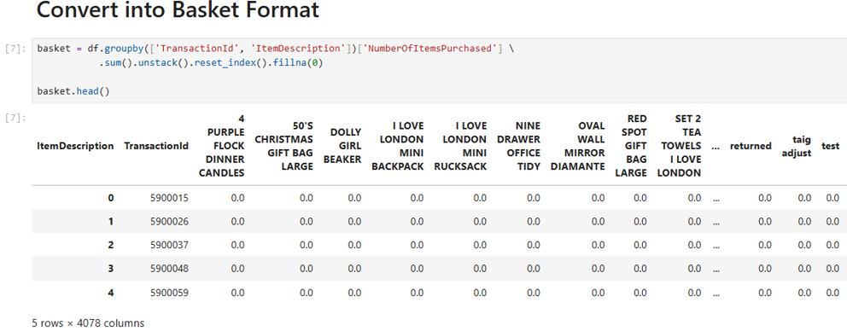
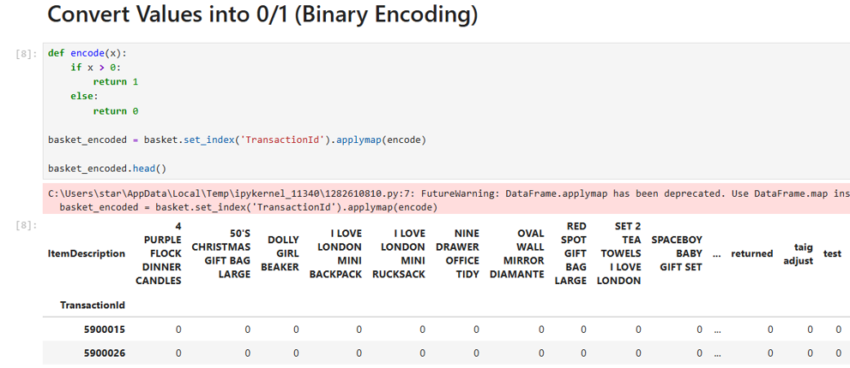
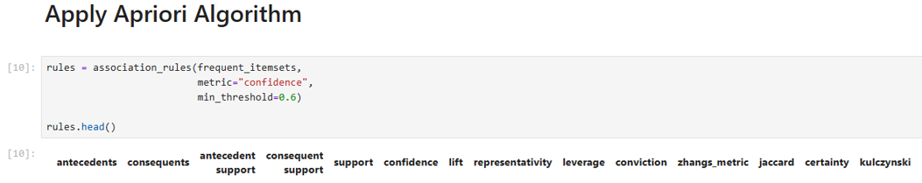
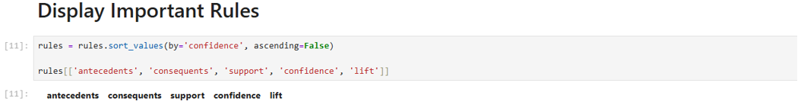
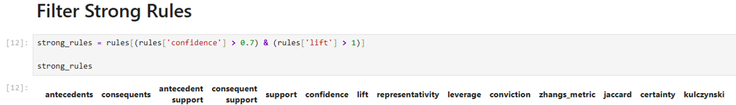

Support threshold analysis
Support Threshold | Frequent Single Items | Frequent Item Pairs | Resulting Rules
0.01 (1%) | 100 | 45 | Multiple rules generated
0.03 (3%) | 98 | 0 | No rules found
0.05 (5%) | 49 | 0 | No rules found

LAB-7: FP-Tree & FP-Growth

1. Objective
The objective of this lab is to implement and analyze the FP-Growth (Frequent Pattern Growth) algorithm for efficient frequent pattern mining. Students will construct an FP-Tree pipeline visually using Orange Data Mining, compare its algorithmic execution performance with the Apriori algorithm , and extract high-confidence transactional rules.
2. Tools & Datasets
- Tool: Orange Data Mining + Python Validation
- Dataset: Large Retail Dataset / Grocery Transactions
3. Background Concepts
While the Apriori algorithm relies on a "candidate generation-and-test" approach that requires scanning the database multiple times, the FP-Growth algorithm introduces a radical performance upgrade. It adopts a divide-and-conquer strategy that encodes the database into a compact data structure called an FP-Tree (Frequent Pattern Tree).
- No Candidate Generation: FP-Growth eliminates the costly candidate generation phase entirely, avoiding the combinatorial explosion of checking millions of item combinations.
- Database Scans: It scans the database exactly twice:
  - Scan 1: Counts the support of individual items and sorts them in descending order of frequency.
  - Scan 2: Constructs the FP-Tree by mapping transactions directly onto overlapping paths.
- Conditional FP-Trees: The algorithm extracts frequent itemsets directly from the tree structure by traversing it bottom-up from the least frequent items using suffix patterns.

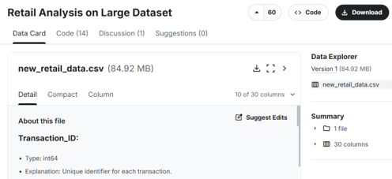
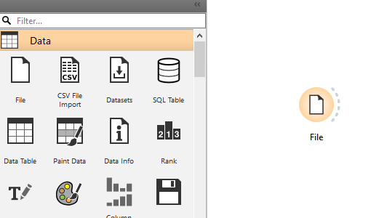
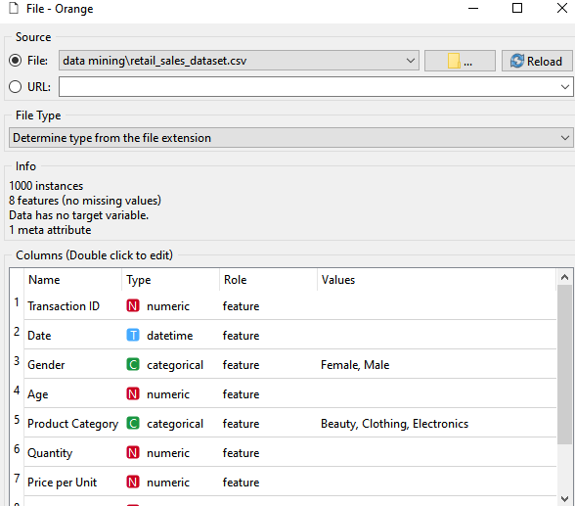
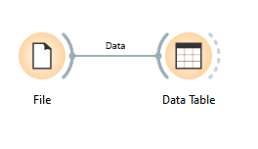
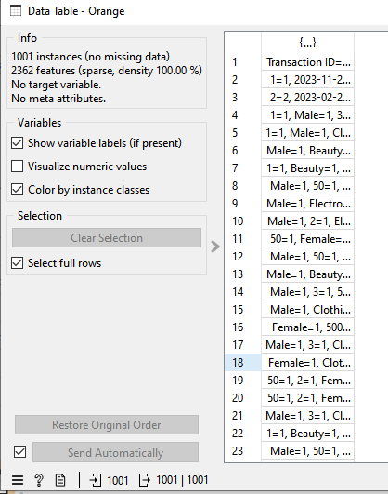
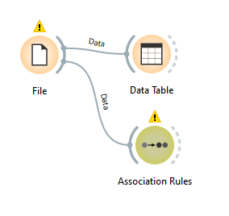
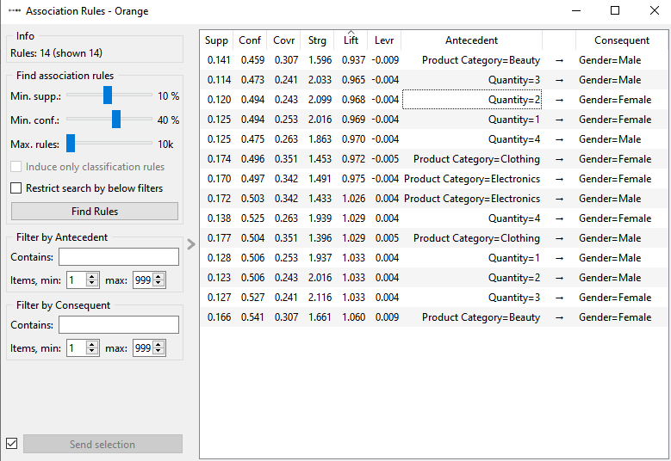
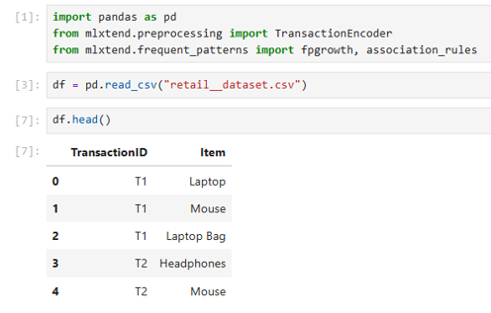
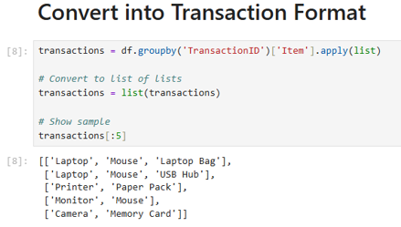
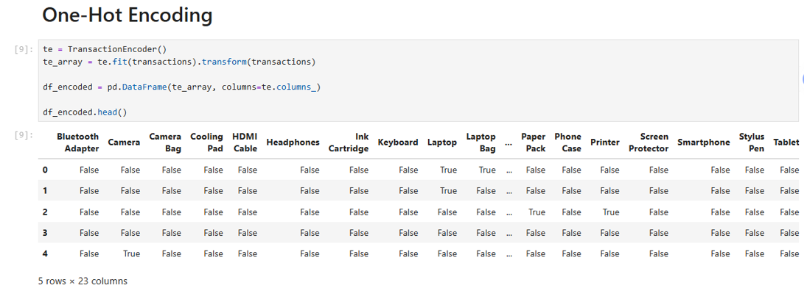
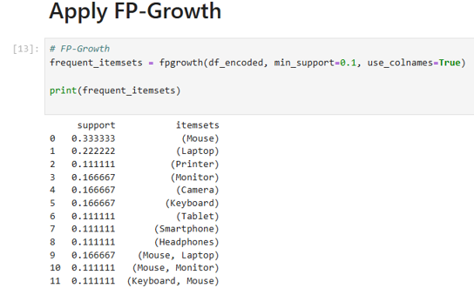
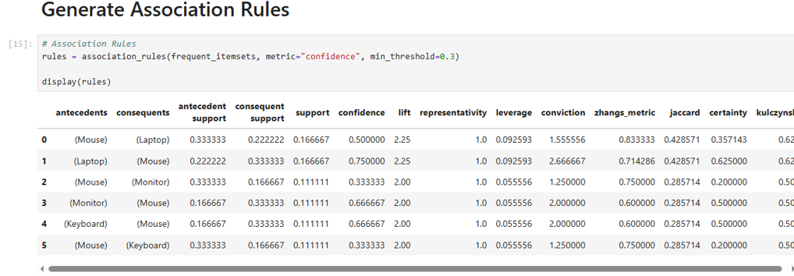
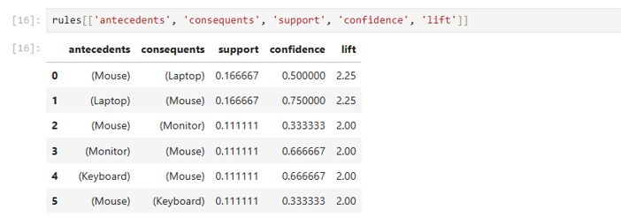

LAB-8: Python Basics for Data Mining

1. Objective
The objective of this lab is to introduce students to the fundamentals of Python programming. Students will learn how to set up an Integrated Development Environment (IDE), work with core data types, implement conditional logic, use loops, and write basic functions.
Python Syntax
Python is a high-level programming language widely used in data mining due to its simplicity and readability. It uses indentation (spacing) to define code blocks instead of brackets.
Example:
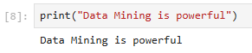
Lists and Dictionaries
- Lists:
Used to store ordered collections of items
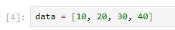
- Dictionaries:
Store data in key-value pairs
Example:
A dataset can be stored as a list of dictionaries where each dictionary represents a record.
OOP Basics (Object-Oriented Programming)
Object-Oriented Programming (OOP) is a programming approach that organizes code using objects and classes.
Key concepts include:
- Classes: Blueprints for creating objects
- Objects: Instances of classes
- Encapsulation: Hiding internal details
- Inheritance: Reusing code from existing classes
- Polymorphism: Using the same method in different ways
Example:
A class Student can have attributes like name and marks, and methods like calculate_grade().

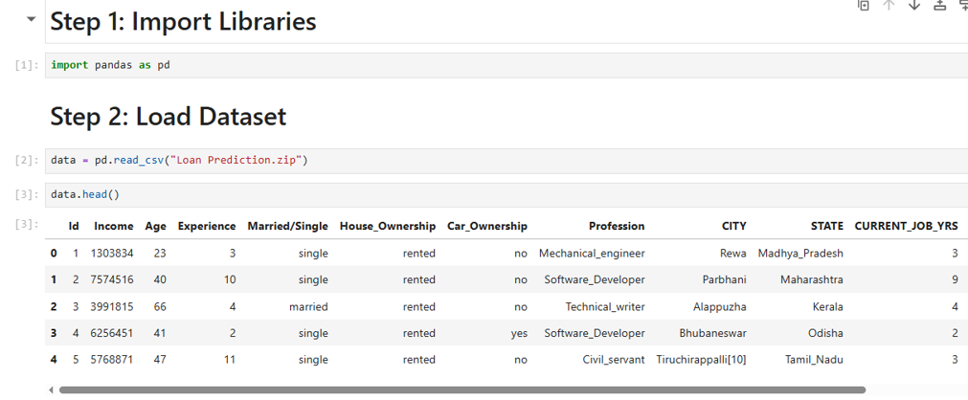
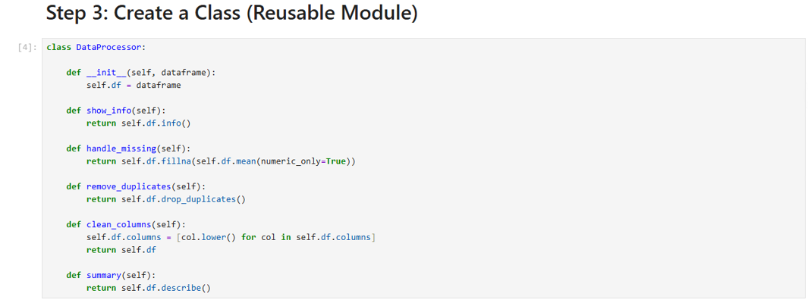
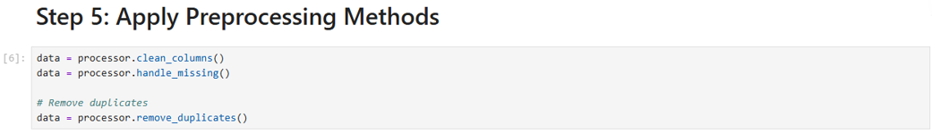
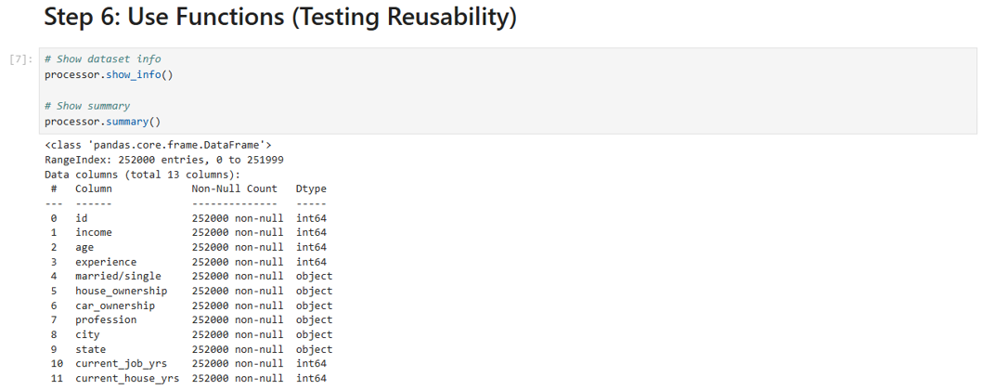
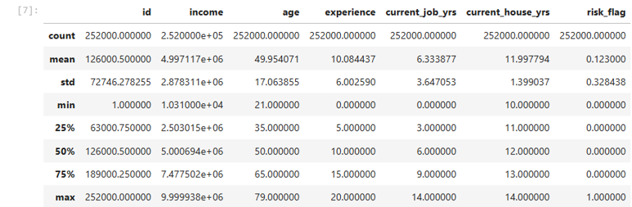
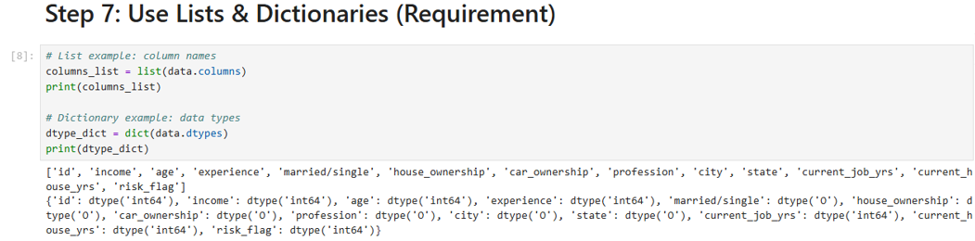

LAB-9: Decision Tree
1. Objective
The objective of this lab is to implement and analyze the Decision Tree algorithm for predictive customer analytics. Students will construct a classification pipeline visually using KNIME Analytics Platform, validate the results programmatically using Python, and evaluate structural predictive metrics to determine consumer purchasing behavior.
2. Tools & Datasets
- Tool: KNIME Analytics Platform + Python Validation
- Dataset: Marketing Dataset
3. Background Concepts
While non-parametric models partition data spaces recursively, the Decision Tree algorithm introduces a highly interpretable, flowchart-like tree structure to solve classification tasks. It splits a heterogeneous dataset into increasingly homogenous subsets based on feature attributes.
- Information Gain & Entropy: Trees utilize mathematical metrics like Entropy to calculate impurity within a node. By choosing splits that maximize Information Gain, the algorithm minimizes the uncertainty of the resulting child branches.
- Gini Impurity: Often used as an alternative splitting criterion, Gini measures how often a randomly chosen element from the set would be incorrectly labeled if it were randomly labeled according to the distribution of labels in the subset.
- Overfitting and Pruning: Decision trees can easily grow overly complex, capturing random noise in the training data.

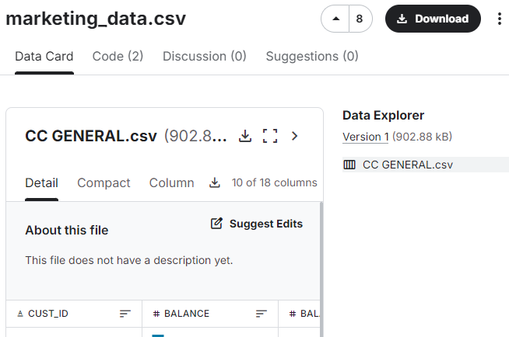
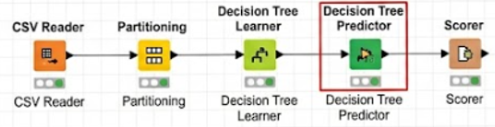
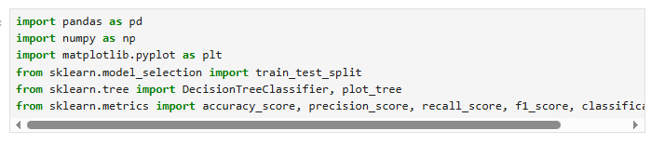
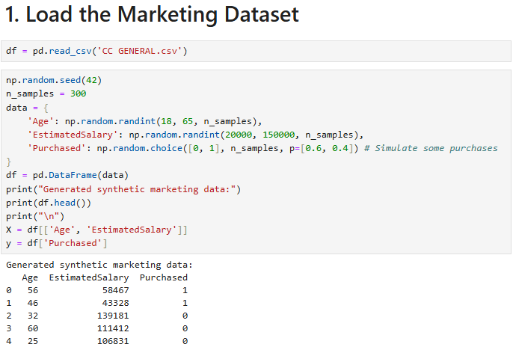
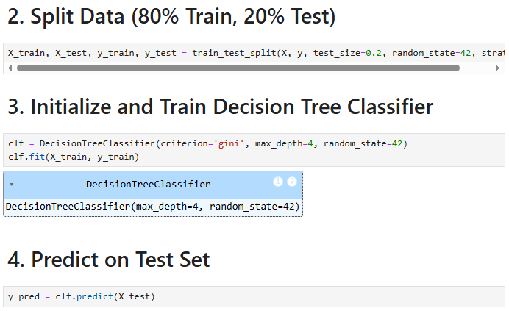
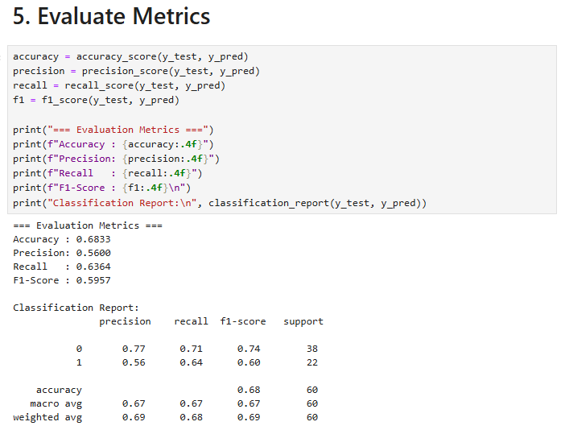
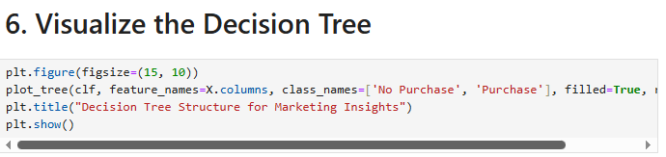
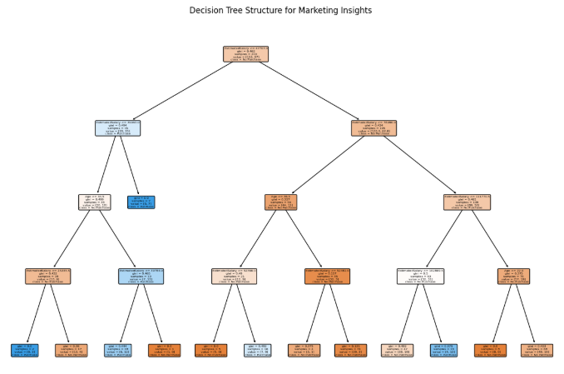

LAB-10: Naïve Bayes & KNN

1. Objective
The objective of this lab is to implement and compare the performance of Naïve Bayes and K-Nearest Neighbors (KNN) classifiers. Students will construct a text/tabular classification workflow using RapidMiner Studio, validate operations in Python, and benchmark comparative error dynamics on a spam filtering dataset.
2. Tools & Datasets
- Tool: RapidMiner Studio + Python Validation
- Dataset: Spam Dataset
3. Background Concepts
Classification architectures handle boundary distributions differently depending on whether they leverage probabilistic assumptions or spatial metrics.
- Naïve Bayes Classifier: A probabilistic model founded upon Bayes' Theorem. It operates on the "naïve" assumption of class conditional independence, meaning the presence of a specific feature in a class is assumed to be completely unrelated to the presence of any other feature.
- K-Nearest Neighbors (KNN): A lazy-learning, instance-based algorithm that skips explicit training phases. It classifies an unlabelled vector by calculating the geometric distance (such as Euclidean metric) between that query point and all historical records, assigning the majority class of its $K$ nearest neighbors.
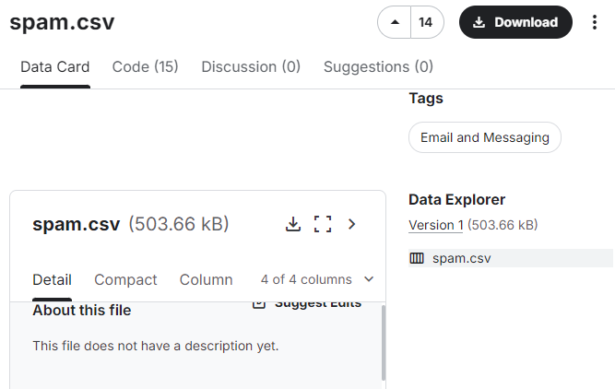
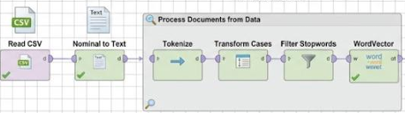
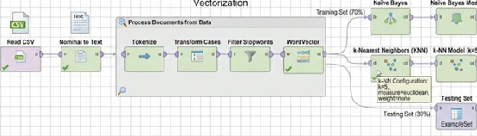
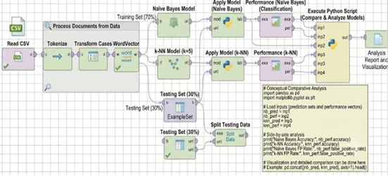
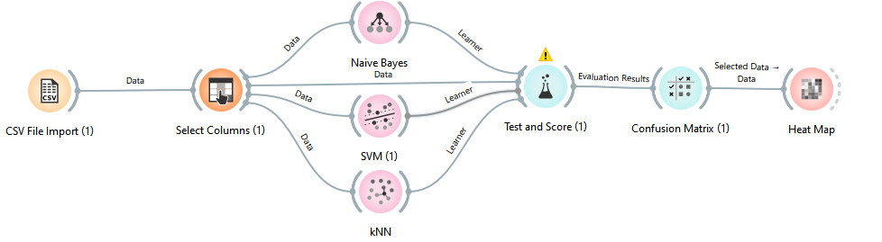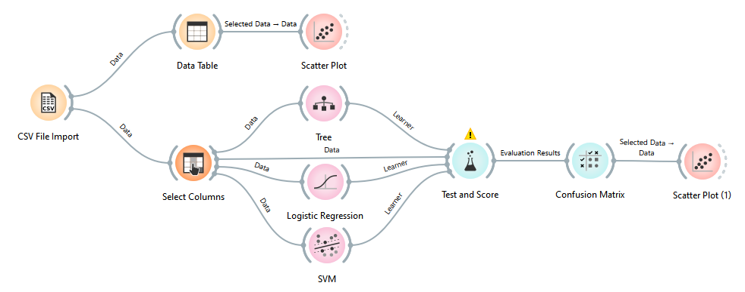
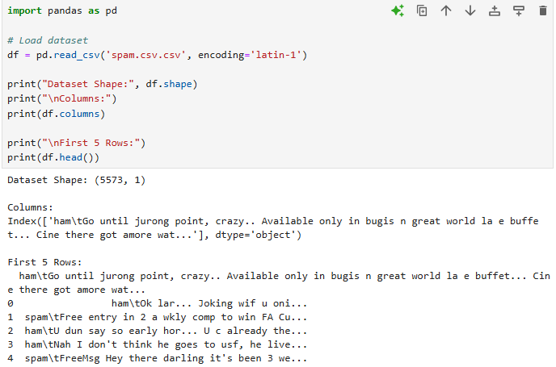
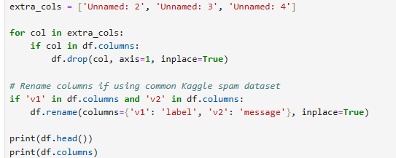
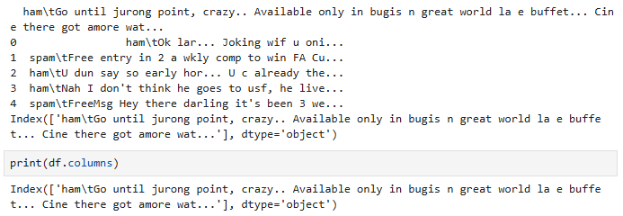
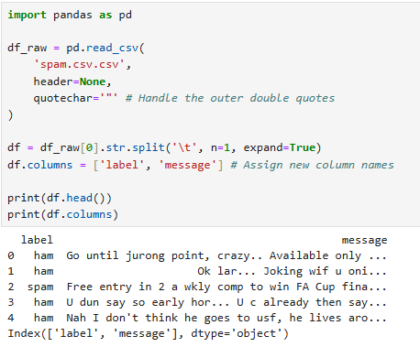
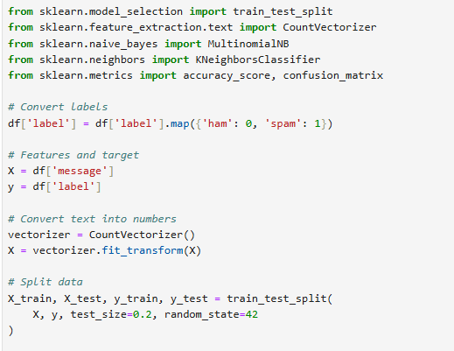
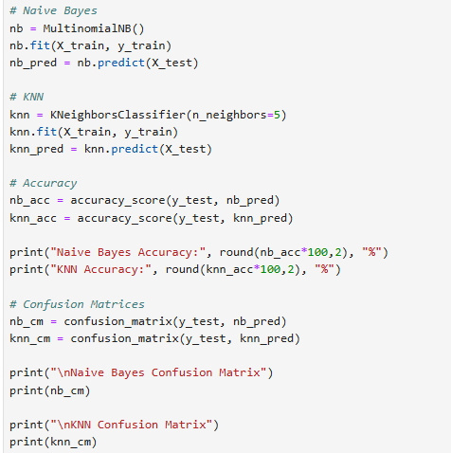
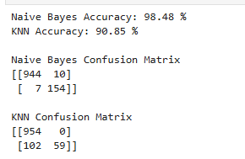
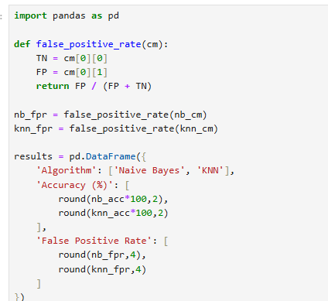
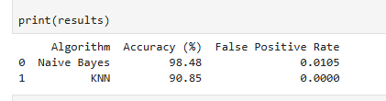

LAB-11: Support Vector Machine (SVM)
1. Objective
The objective of this lab is to implement and assess Support Vector Machines (SVM) for high-dimensional risk modeling. Students will map decision boundaries using KNIME Analytics Platform, leverage Python validation libraries, and investigate how kernel tricks isolate fraudulent transactions.
2. Tools & Datasets
- Tool: KNIME Analytics Platform + Python Validation
- Dataset: Fraud Detection Dataset
3. Background Concepts
When working with complex datasets where categories overlap, linear partitioning is insufficient. Support Vector Machines (SVM) handle this by finding a boundary that cleanly separates classes while maximizing spatial margins.
- Hyperplanes and Support Vectors: The algorithm searches for an optimal decision hyperplane that maximizes the geometric distance (margin) between the closest data points of opposing classes, known as support vectors.
- The Kernel Trick: For non-linearly separable data, SVM applies mathematical kernels to transform the lower-dimensional input space into a higher-dimensional feature space where a linear boundary can separate the classes.
- Linear vs. RBF Kernels: A Linear kernel splits data along straight vector cuts. The Radial Basis Function (RBF) kernel measures localized structural distances, projecting non-linear circular or localized boundaries.
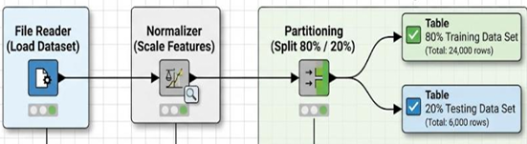
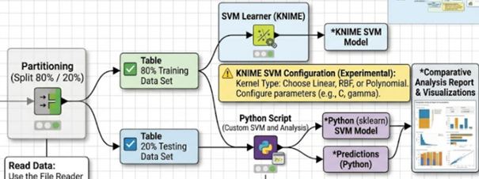
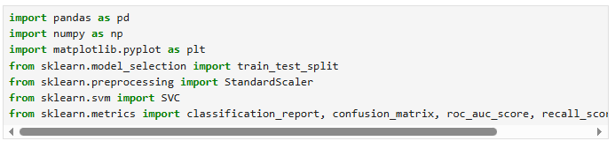
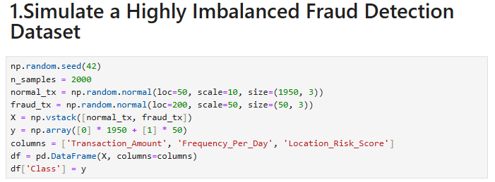
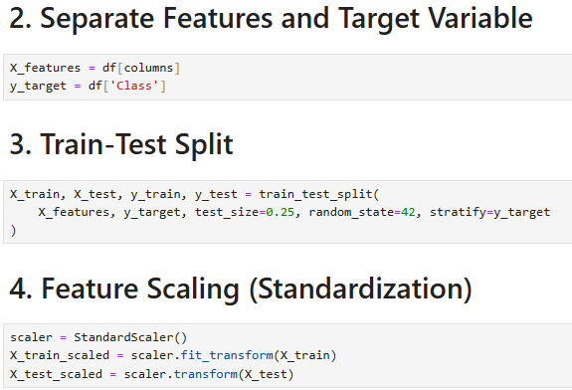
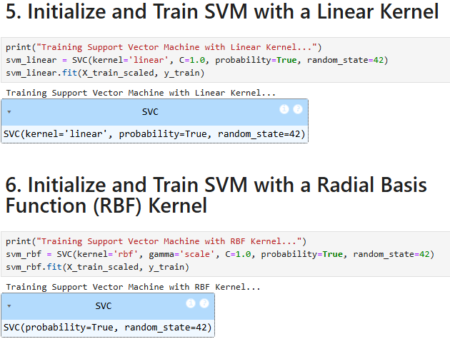
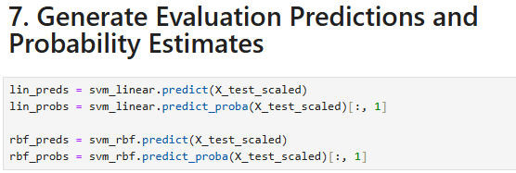
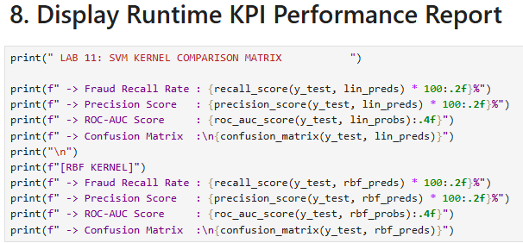
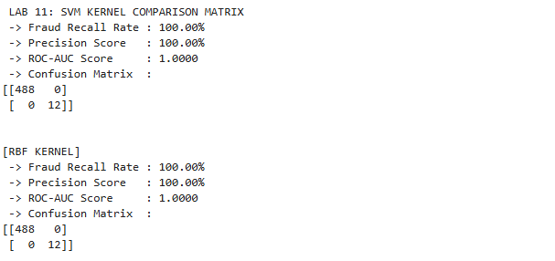
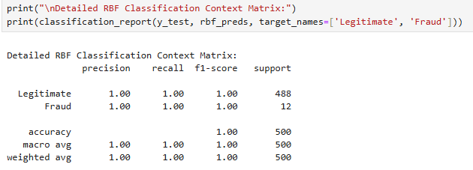

LAB-12: Clustering Algorithms
1. Objective
The objective of this lab is to implement and analyze unsupervised K-Means and Hierarchical Clustering algorithms. Students will construct a customer segmentation visualization pipeline inside Orange Data Mining, validate structural cohesion with Python, and evaluate cluster separation profiles.
2. Tools & Datasets
- Tool: Orange Data Mining + Python Validation
- Dataset: Mall Customer Dataset
3. Background Concepts
Unsupervised data mining does not rely on predefined labels. Instead, it uncovers hidden structures within a dataset by grouping records based on feature similarity.
- K-Means Clustering: A centroid-based algorithm that partitions data into $K$ distinct clusters. It iteratively updates cluster centroids by minimizing the within-cluster Sum of Squared Errors (SSE).
- Hierarchical Clustering: A connectivity-based approach that creates a bottom-up tree structure called a Dendrogram. It merges individual items into groups based on linkage criteria like ward variance or complete distance metrics.
- The Elbow Method & Silhouette Coefficients: Because $K$ must be selected beforehand, engineers plot inertia variations to locate an "elbow bend," or calculate individual silhouette widths to measure how well each point fits within its assigned group compared to neighboring clusters.

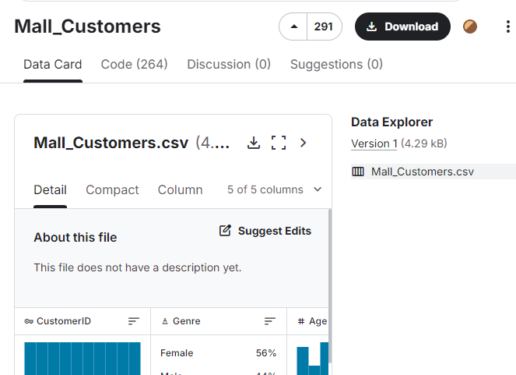
Lab work on orange
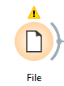
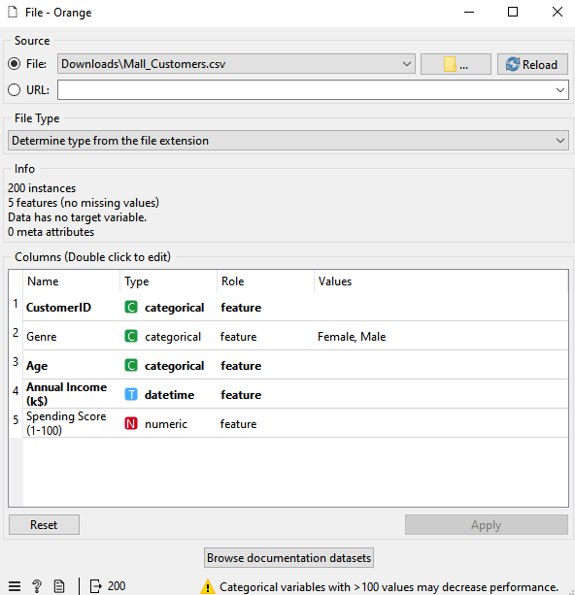
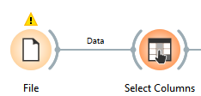
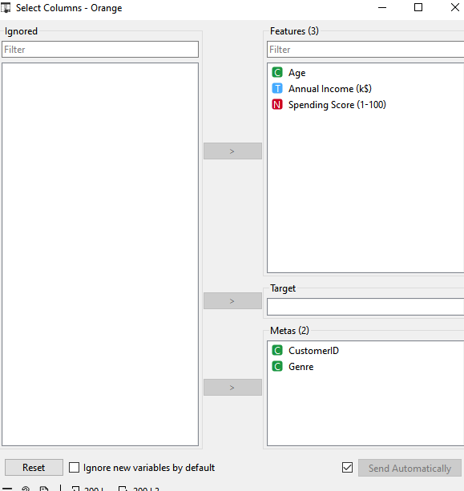
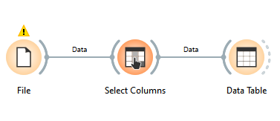
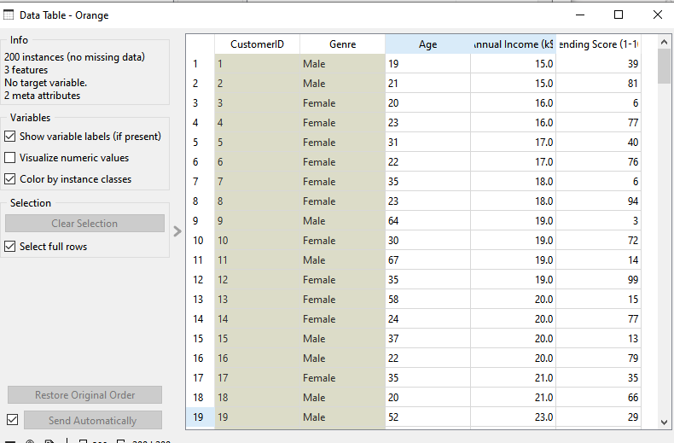
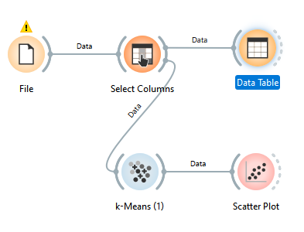
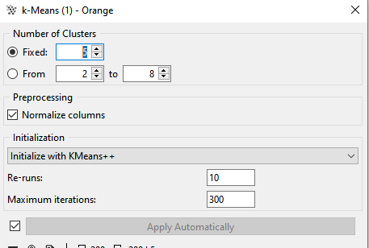

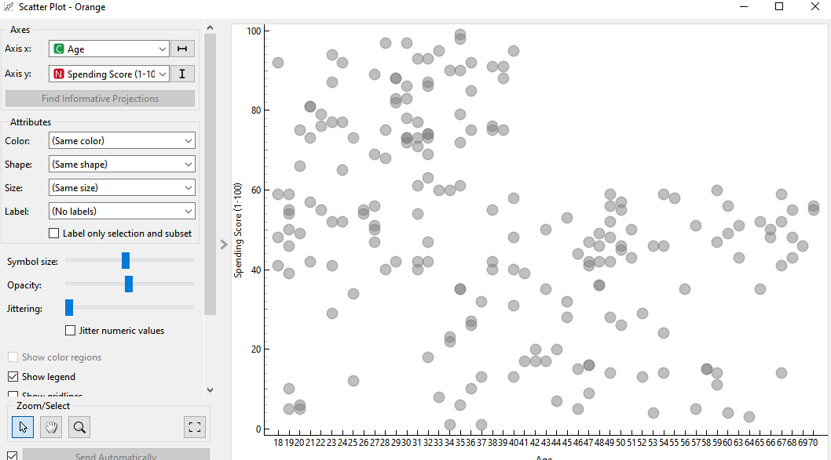
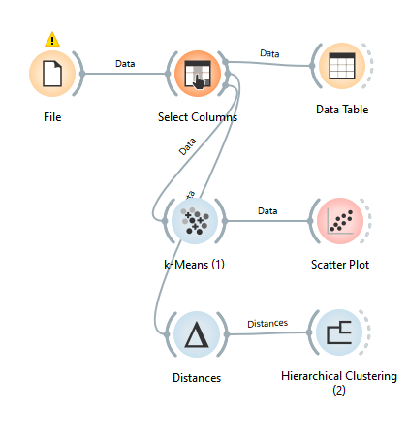
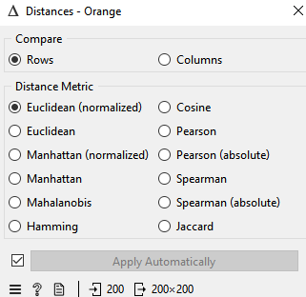
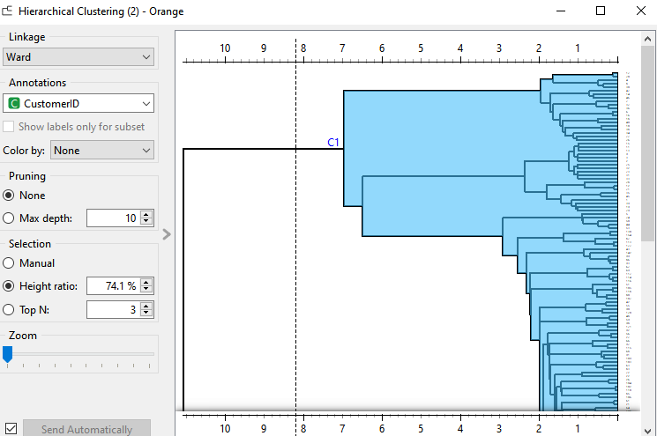
Lab Work on python
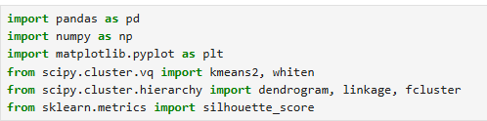
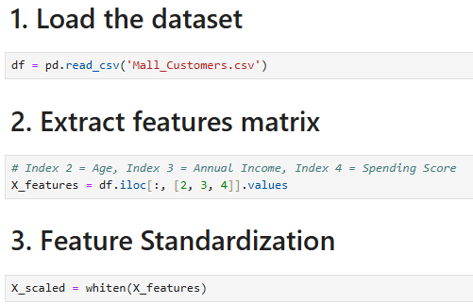
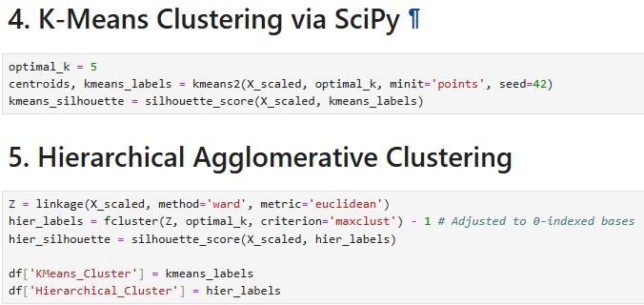
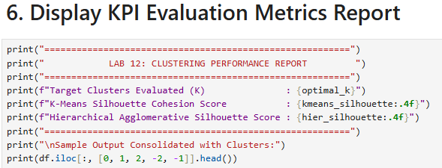
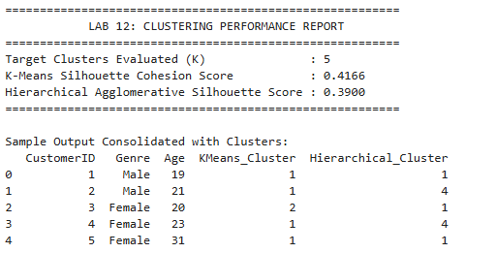
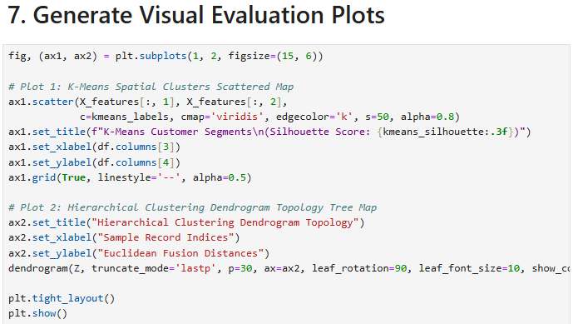
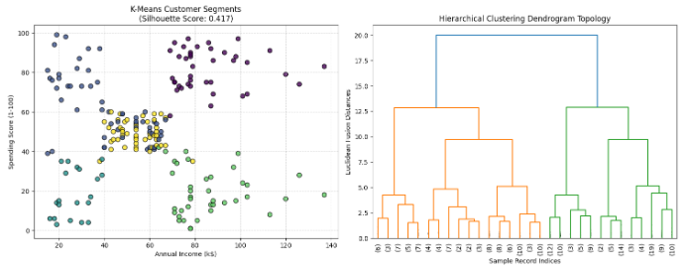

LAB-13: Outlier Detection Techniques
1. Objective
The objective of this lab is to implement and analyze distance-based and density-based anomaly mining techniques. Students will construct an outlier isolation framework inside RapidMiner Studio, validate isolation vectors with Python, and identify abnormal transactions.
2. Tools & Datasets
- Tool: RapidMiner Studio + Python Validation
- Dataset: Banking Dataset
3. Background Concepts
Anomalies represent patterns that deviate significantly from normal behavior, often indicating fraud, system failures, or data entry errors.
- Distance-Based Outlier Detection: Evaluates localized space anomalies by measuring the geometric distance from a target record to its nearest neighbors within the feature space. Points located far from dense point clouds are flagged as outliers.
- Isolation Forest (iForest): An ensemble method that isolates anomalies instead of profiling normal data points. Because anomalies require fewer random splits to isolate within a tree structure, they appear noticeably closer to the root of the tree.
- Local Outlier Factor (LOF): A density-based algorithm that measures the local density deviation of a given data point relative to its $k$-nearest neighbors. Points with a substantially lower density than their surrounding neighbors are flagged as outliers.
- Contamination Rate: A user-defined hyperparameter specifying the expected proportion of outlier anomalies hidden within the target dataset (e.g., 0.05 implies a $5\%$ anomaly expectation)
Work on
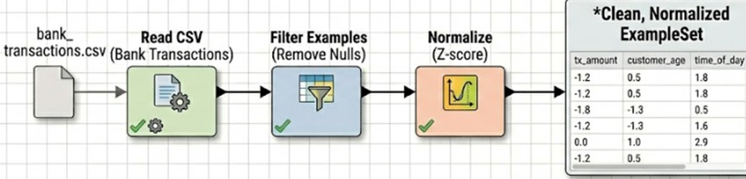
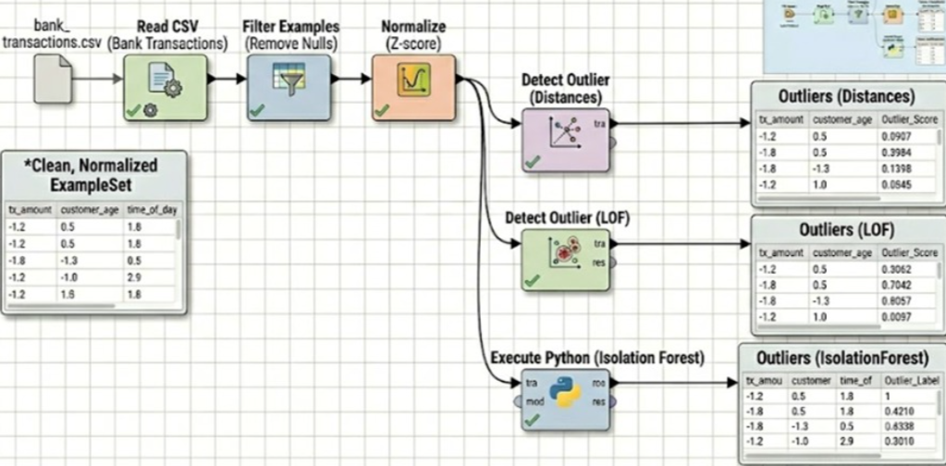
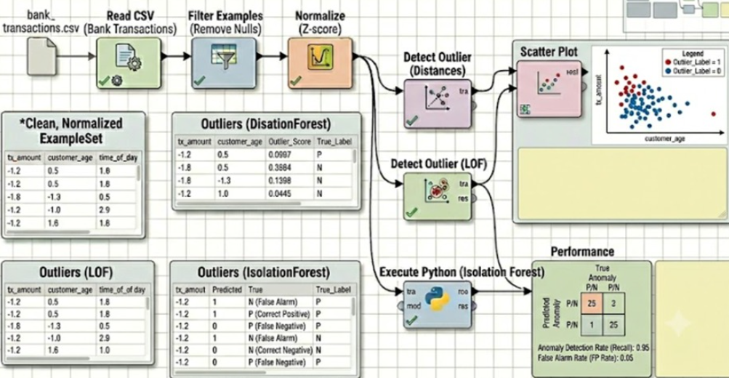

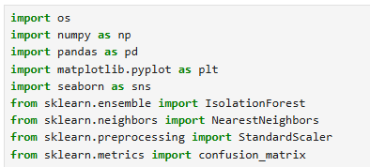
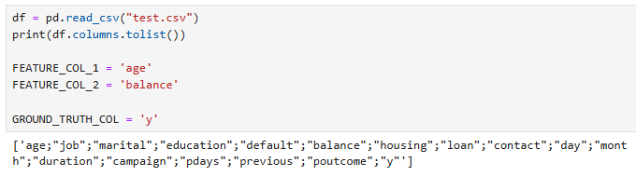
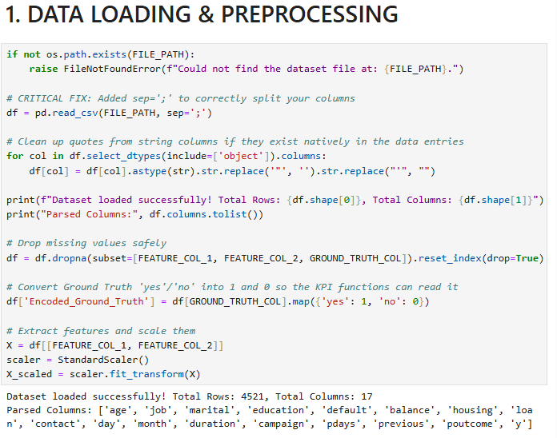
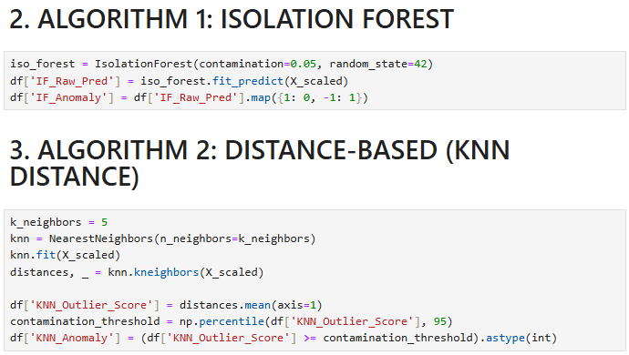
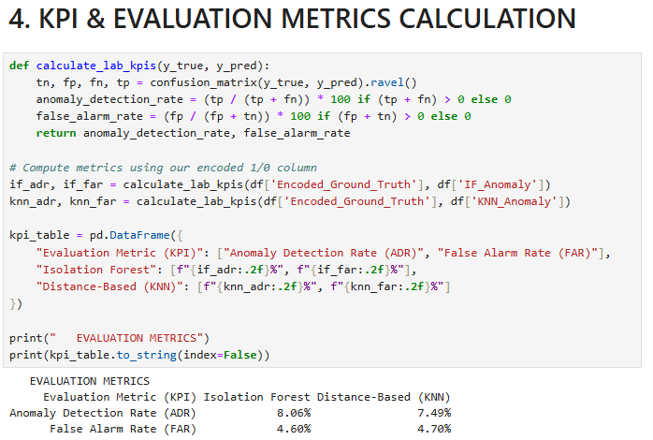
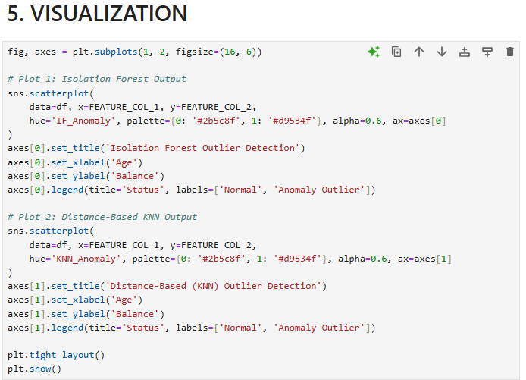
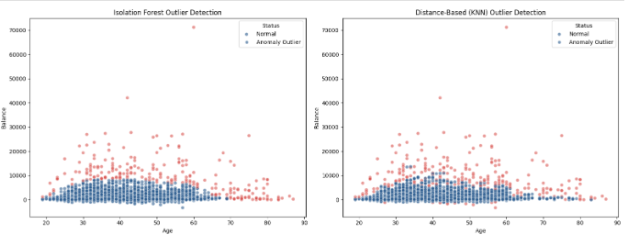

LAB-14: Web Scraping & Sentiment Analysis

1. Objective
The objective of this lab is to implement an end-to-end unstructured natural language processing pipeline. Students will extract online product reviews via programmatic web scraping, apply text normalization techniques, perform sentiment classification, and construct network maps using Gephi or Citespace.
2. Tools & Datasets
- Tool: Citespace / Gephi + Python Engine
- Dataset: Social Media / Review Dataset
3. Background Concepts
Unstructured text data from social media and review platforms provides rich insight into consumer preferences, but must be systematically processed before analysis.
- Text Preprocessing Pipelines: Converts raw, unstructured text into structured features using steps like tokenization, stop-word removal, and lemmatization.
- Sentiment Polarity Scoring: Uses rule-based or algorithmic models to classify text into a continuous or categorical range representing positive, negative, or neutral sentiment.
- Co-occurrence Network Mapping: Maps relationships between frequent terms or entities, revealing thematic connections within the text corpus.

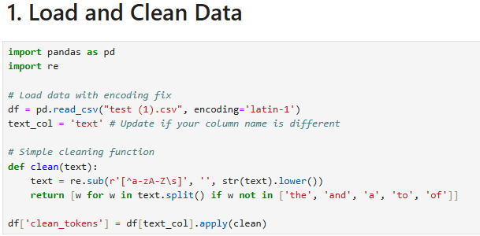
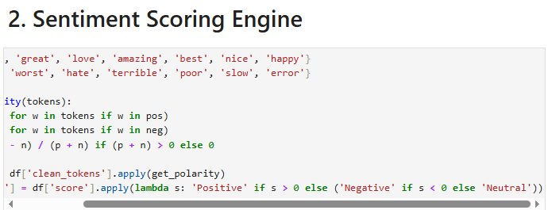
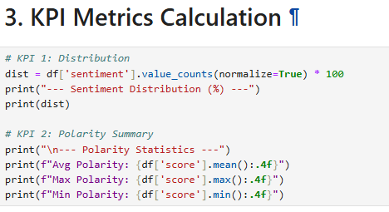
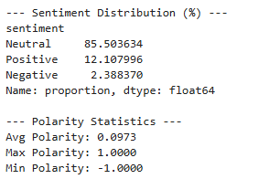
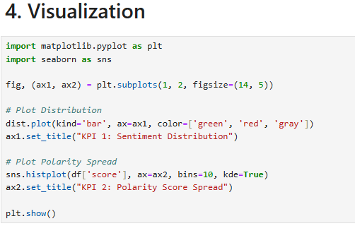
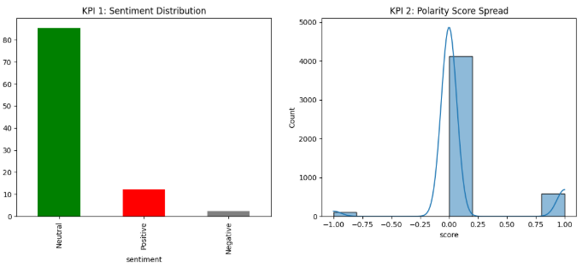
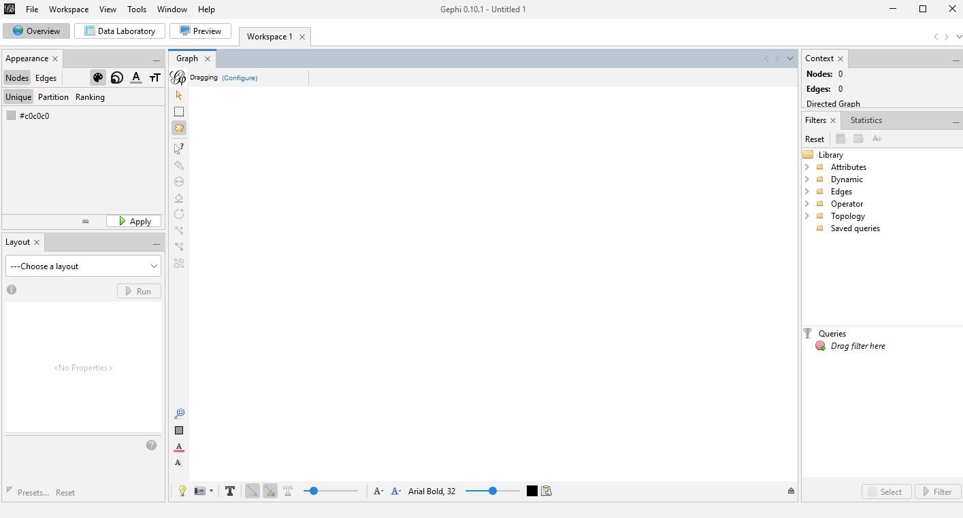
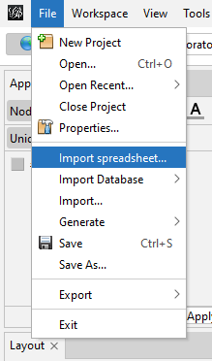
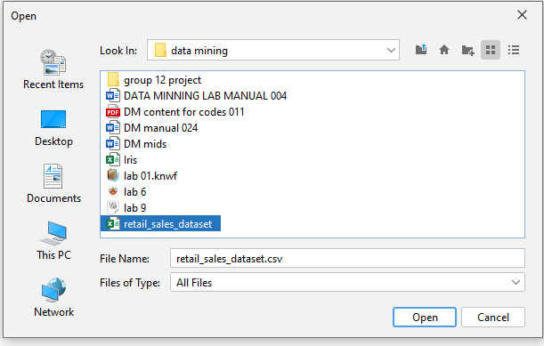
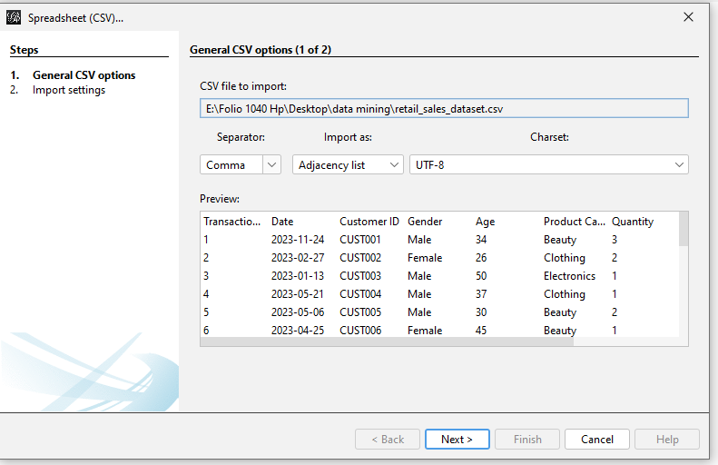
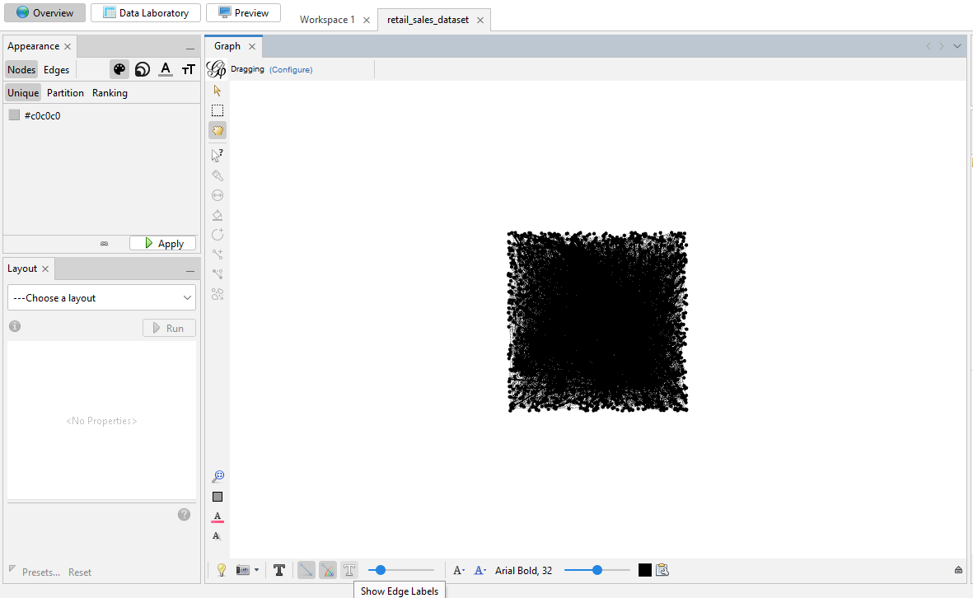
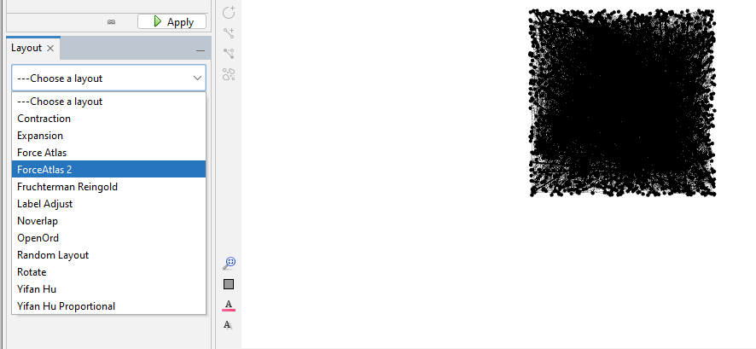
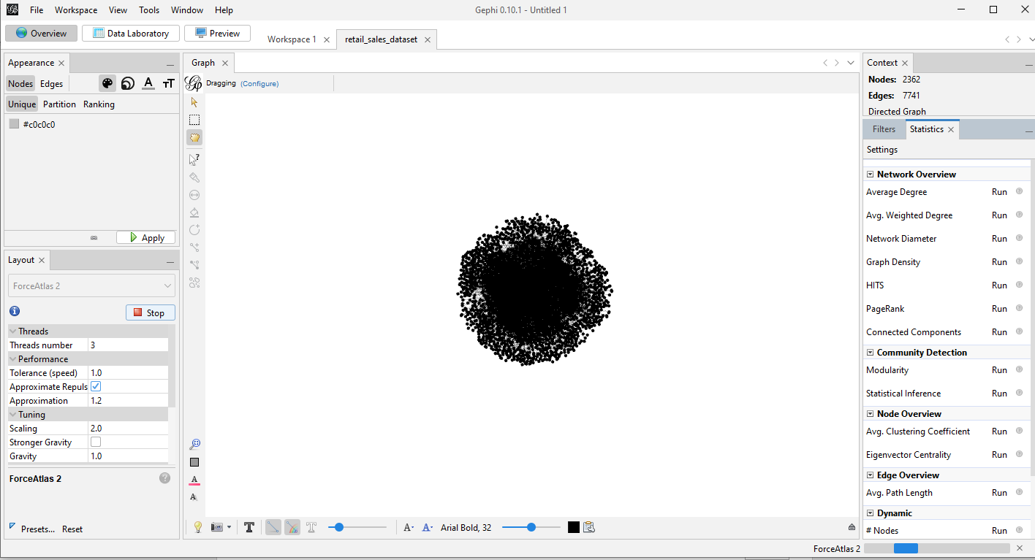
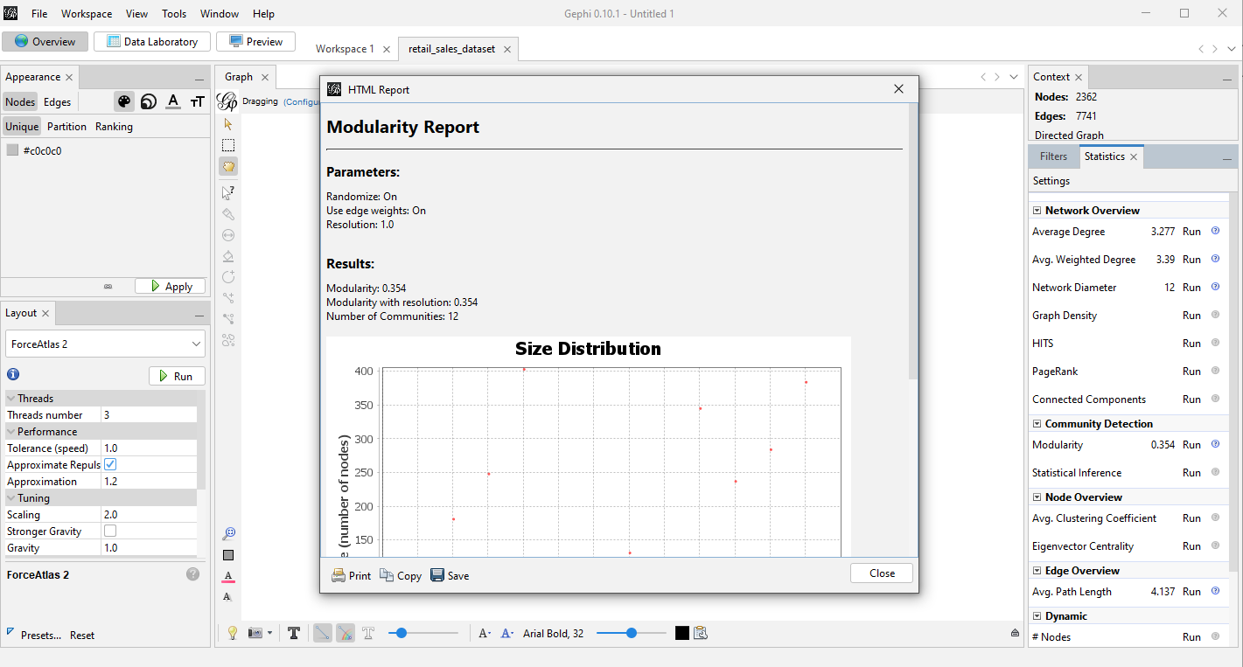
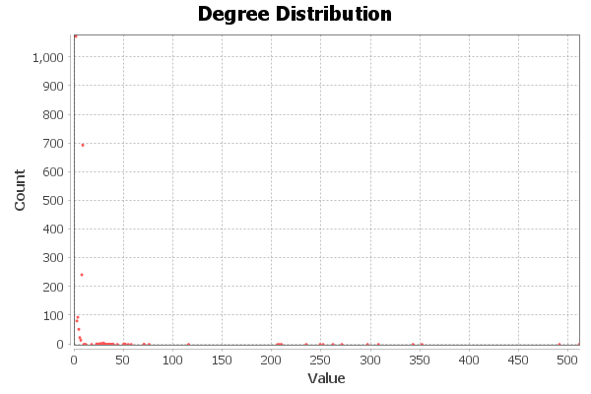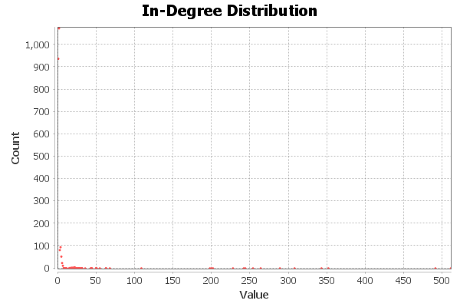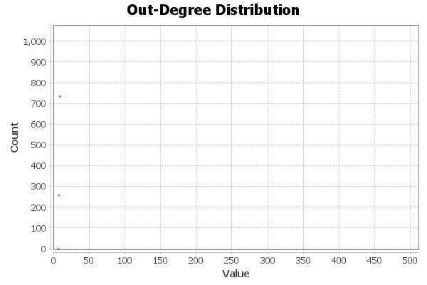
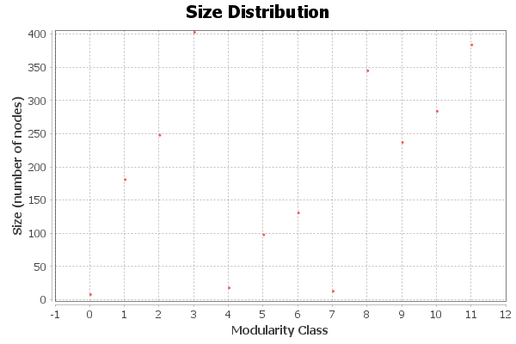
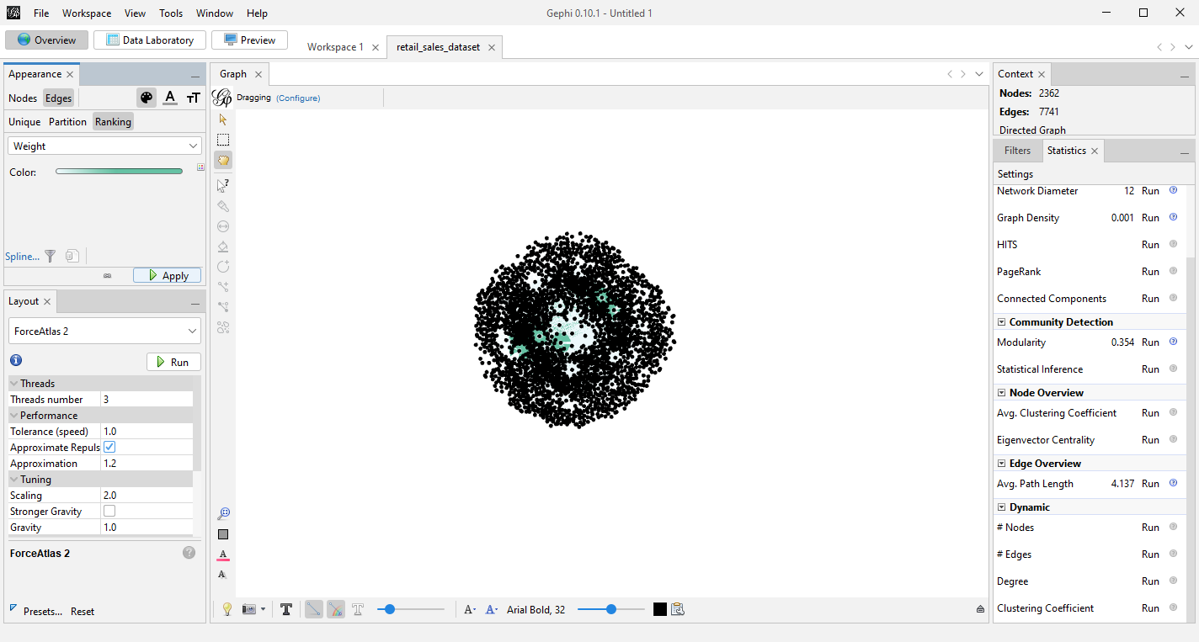
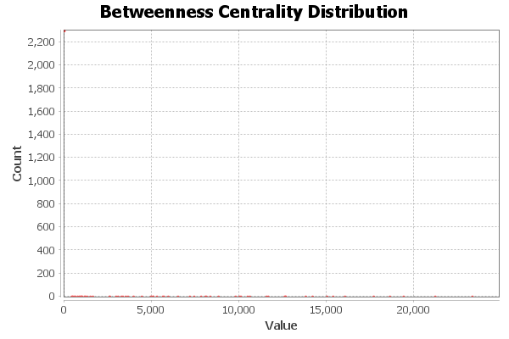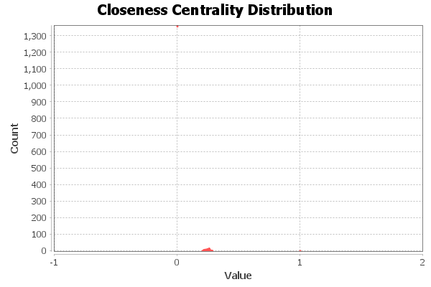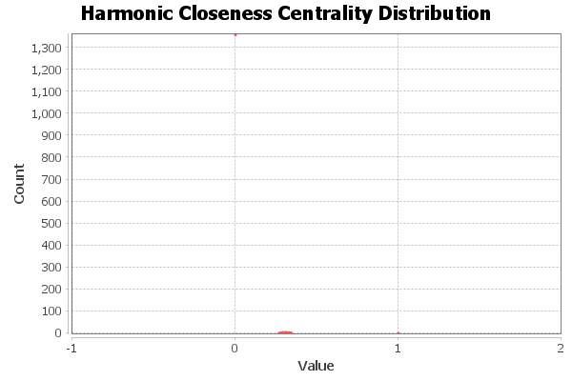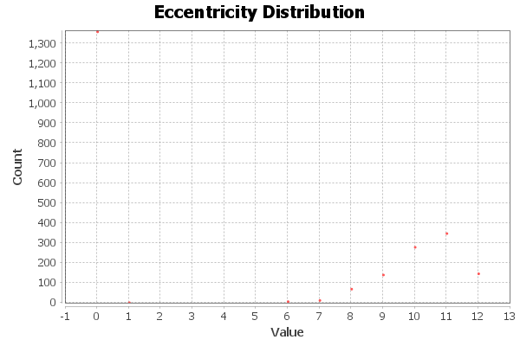
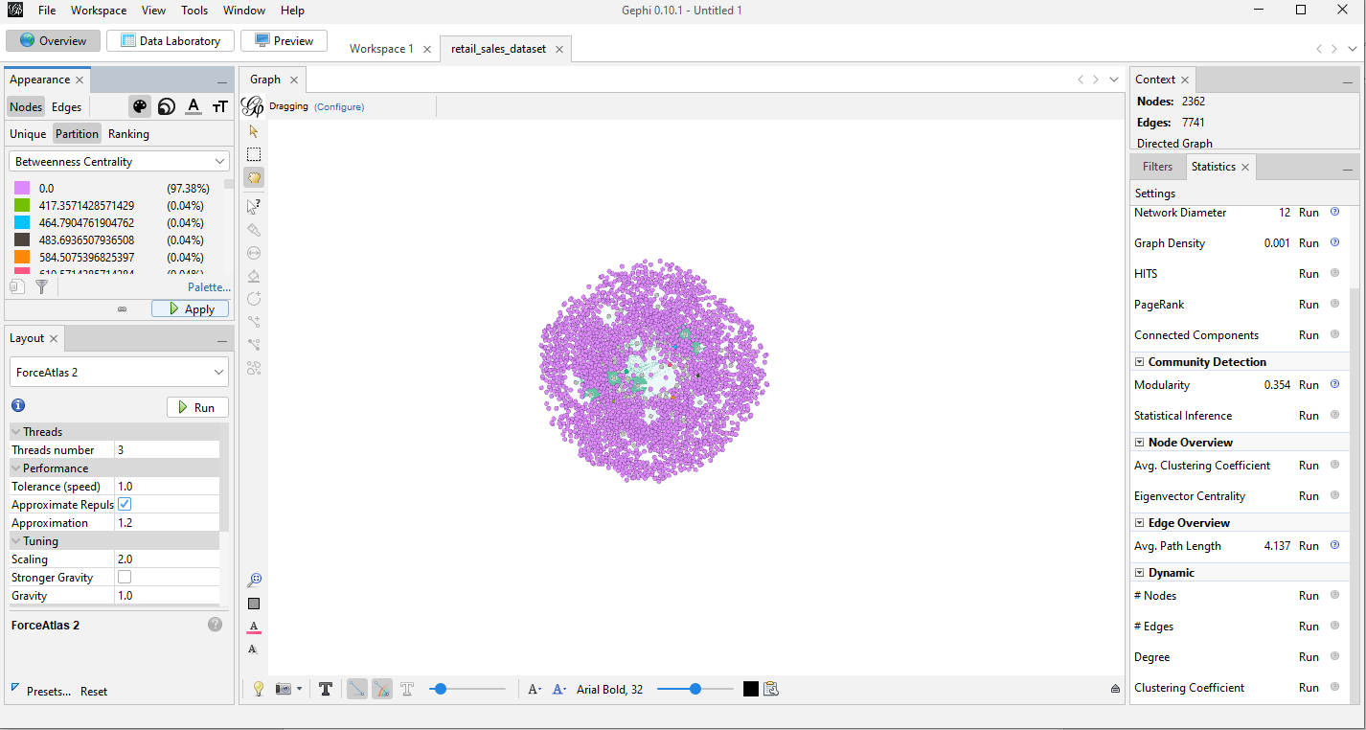
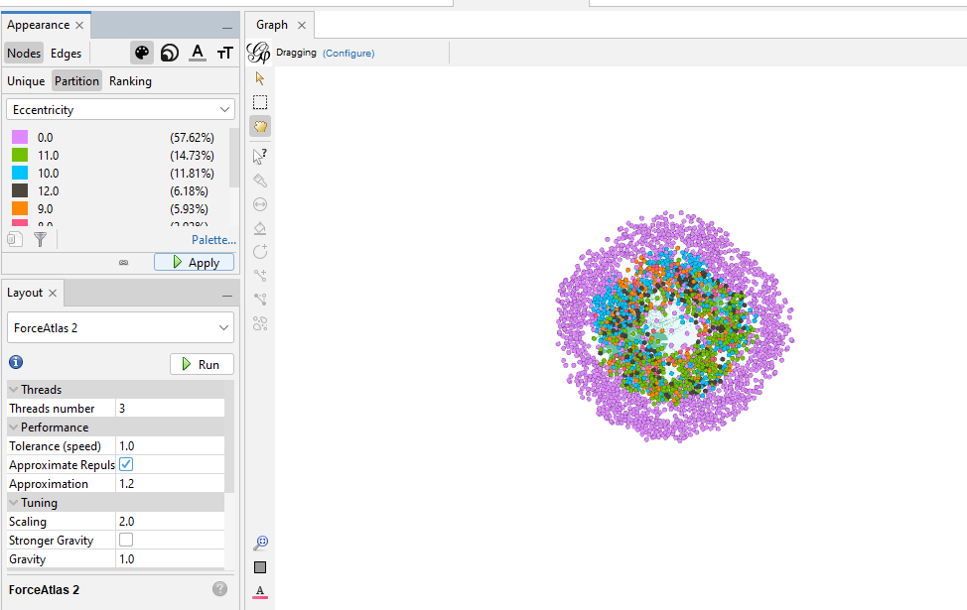
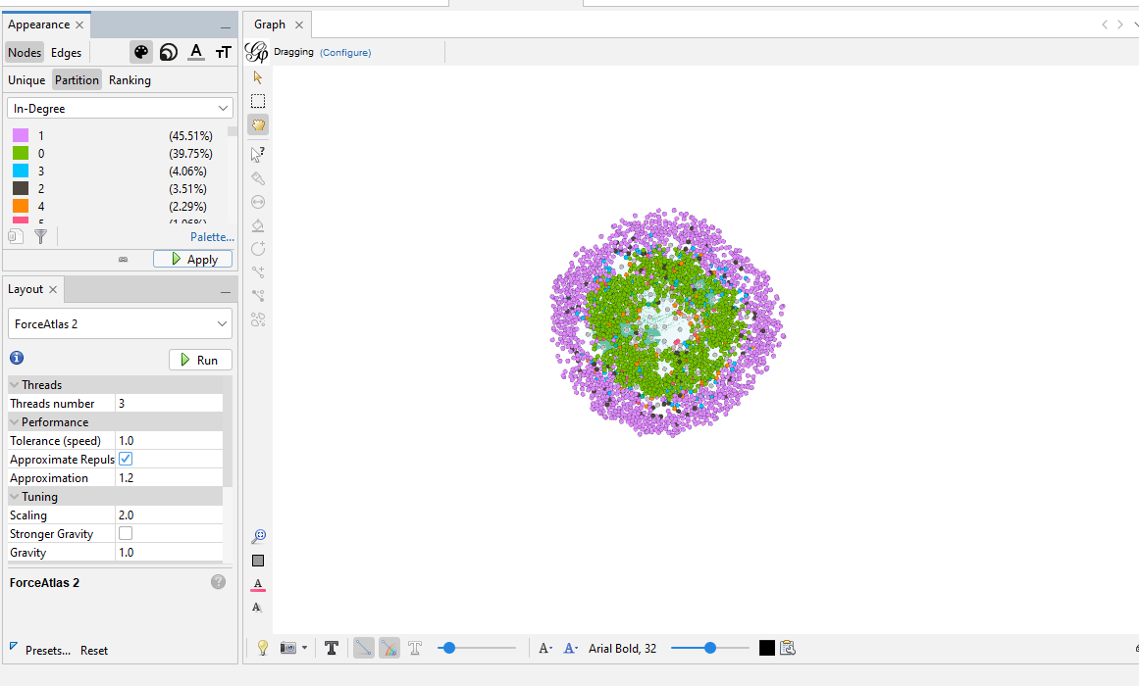
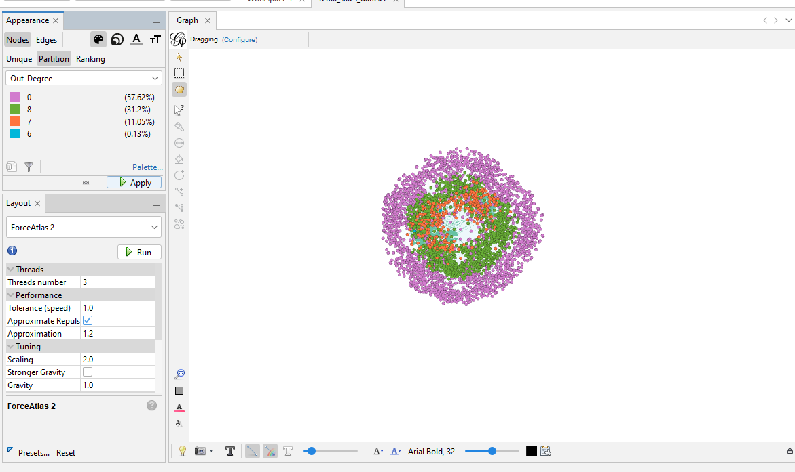
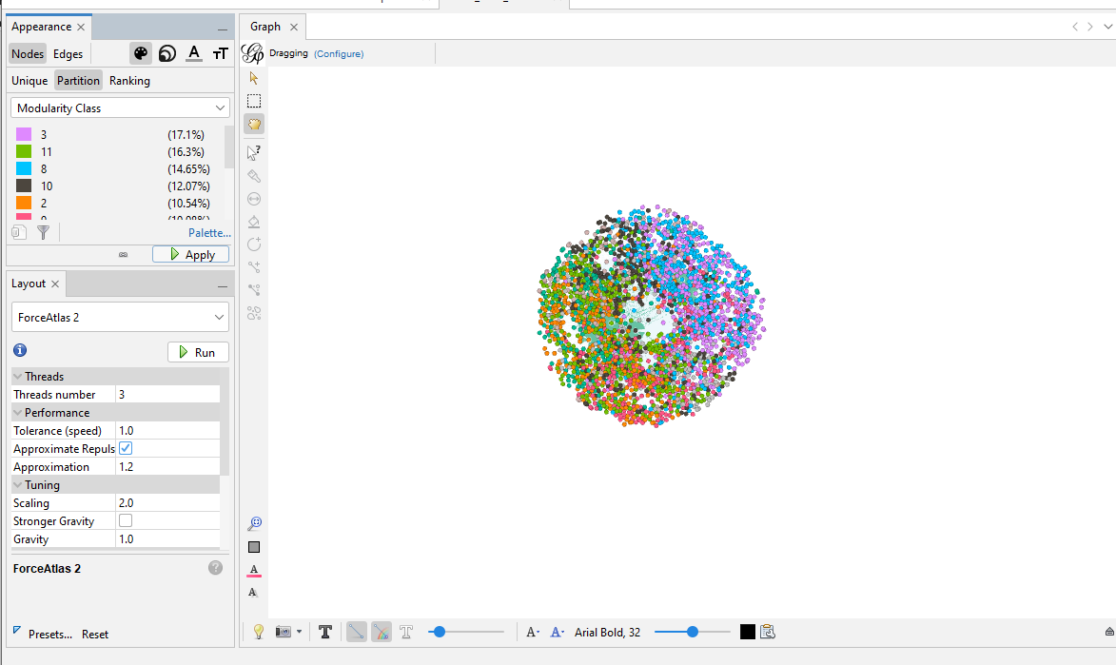
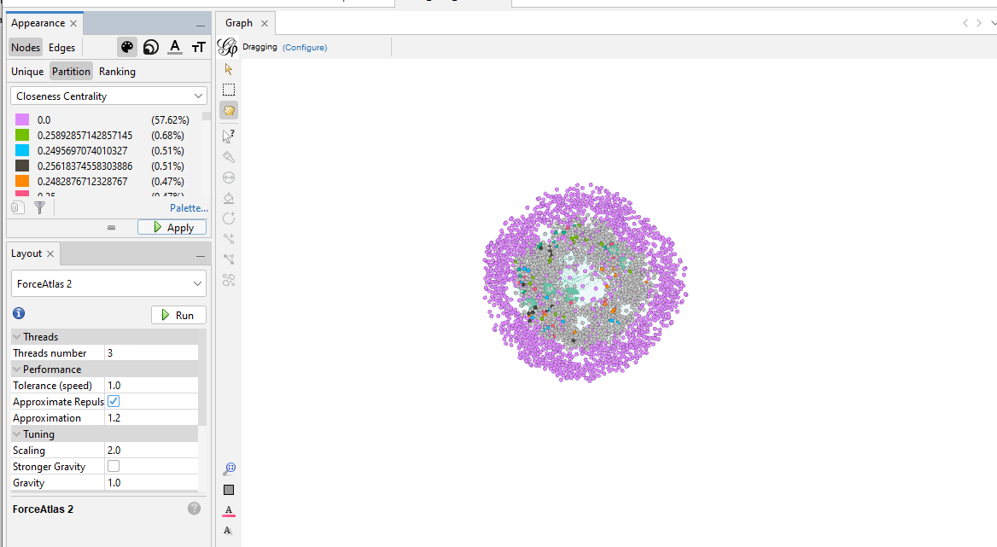
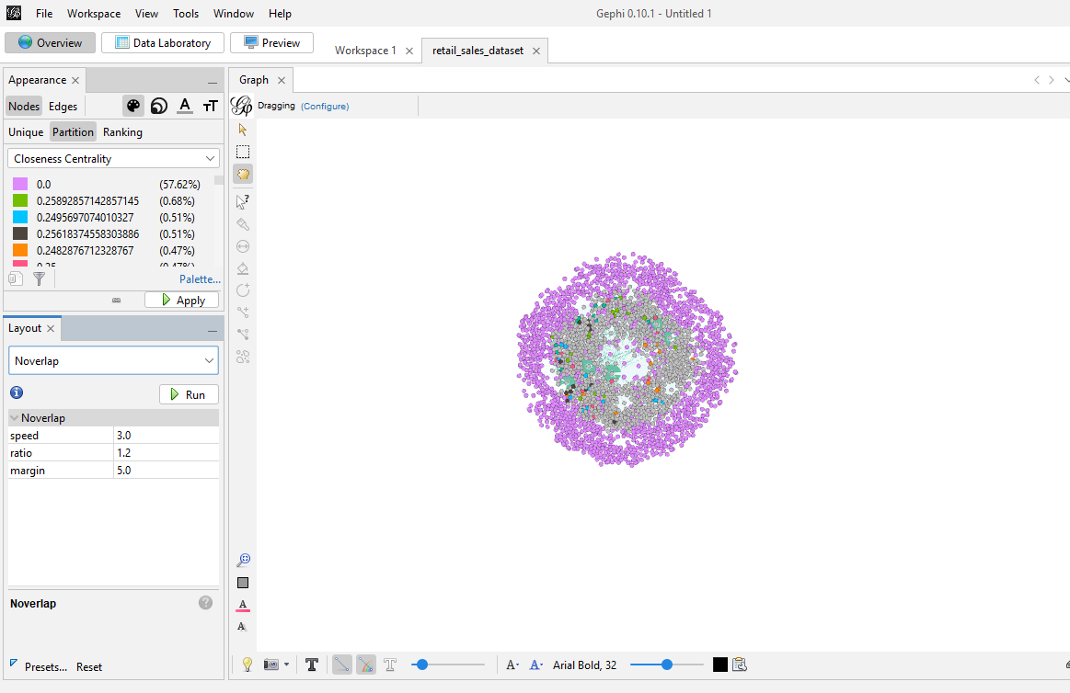
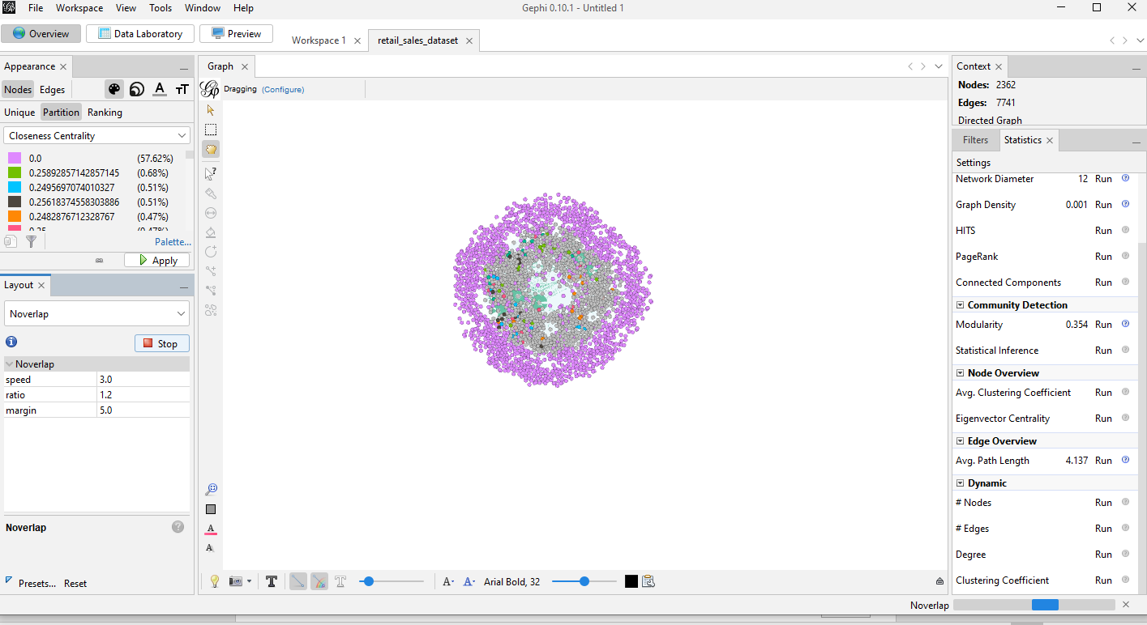
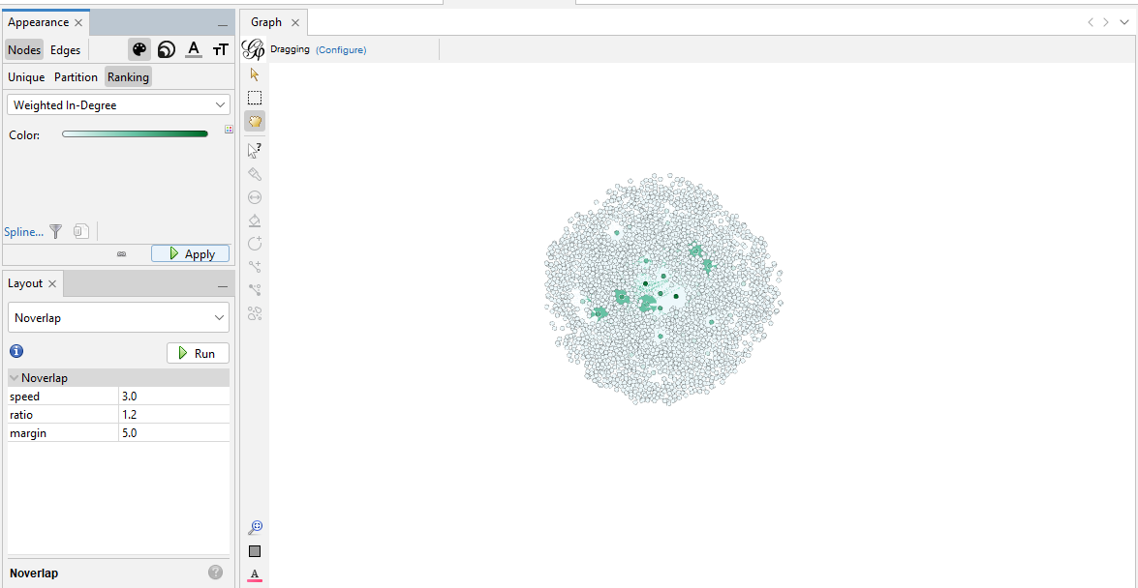
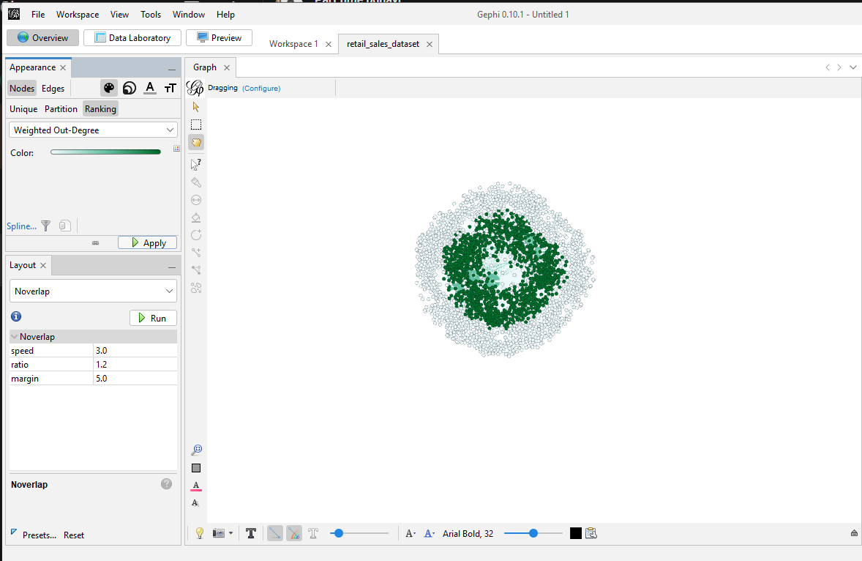

Lab 15: Final Capstone Project
1. Objective
The objective of this final capstone lab is to execute an end-to-end data mining solution addressing an industrial business problem. Students will handle the entire lifecycle, including data ingestion, normalization, modeling across 8 distinct algorithms, comparative performance benchmarking, and formulating data-driven strategic business recommendations.
2. Tools & Datasets
- Tool: Student Choice (KNIME, RapidMiner, Orange, or Python)
- Dataset: Any Approved Complex Industry Dataset
3. Background Concepts
The final capstone synthesizes the data mining techniques covered throughout the course into a cohesive workflow using the CRISP-DM methodology. Rather than focusing on a single algorithm, students evaluate multiple model classes to identify the optimal solution for their specific dataset
4. Evaluation Framework & Deliverables
Students are not provided step-by-step instructions for this capstone. Instead, projects are evaluated based on the rigorous engineering criteria outlined below:
- Comprehensive Pipeline Deployment: Construct a documented data pipeline handling ingestion, feature scaling, and addressing any class imbalances.
- 8-Model Execution Matrix: Train and validate 8 distinct model families covered during the semester (e.g., Decision Trees, Naïve Bayes, KNN, SVM, Logistic Regression, Random Forests, Gradient Boosted Trees, and Neural Networks).
- Comparative Performance Analysis: Consolidate evaluation metrics into a standardized performance dashboard.

